

Event zone

SOFTWARE REQUIREMENTS SPECIFICATIONS

**Project code: EZ**

**Document code: EZ_** **SoftwareRequirementsSpecifications_v1.1**

**Hoa Lac, September 30th 2015**

Signature page

Author： Phan Thanh Vu 19/9/2015

Project Manager

Nguyen Van Cuong 20/9/2015

Technical Leader

Nguyen Ngoc Duong 20/9/2015

Dev #1

Nguyen Thi Chuong 20/9/2015

Dev #2

Duong Thi Lan Anh 20/9/2015

Dev #3

Nguyen Sen Ha 20/9/2015

Dev #4

Reviewer： Nguyen Van Cuong 20/9/2015

Technical Leader

Authorizer： Tran Binh Duong 20/9/2015

Supervisor

**Change History**

**\*A - Added M - Modified D – Deleted**

|  |  |  |  |  |  |
| --- | --- | --- | --- | --- | --- |
| Effective Date | Changed Item | A* M, D | Change Description | Reason of Change | Version |
| 19/9/2015 | Create New | A | Create Document |  | 1.0 |
| 30/9/2015 | M,D | M,D | Modified Use Case  Remove Prototype Part |  | 1.1 |
| 4/10/2015 | M | M | Modified Prototype |  | 1.2 |
|  |  |  |  |  |  |
|  |  |  |  |  |  |
|  |  |  |  |  |  |
|  |  |  |  |  |  |
|  |  |  |  |  |  |
|  |  |  |  |  |  |
|  |  |  |  |  |  |
|  |  |  |  |  |  |

Contents

1. Introduction 6

1.1 Purpose 6

1.2 Scope 6

1.3 Definitions, Acronyms and Abbreviations 6

1.4 References 7

1.5 Overview 7

2. Overall Description 7

2.1 Product Perspective 7

2.2 User Characteristics 8

2.3 Constraints 8

3. Required Specifications 9

3.1 Functional Requirements 9

3.1.1 User Functions 12

3.1.2 Moderator Functions 63

3.1.3 Admin Functions 76

3.2 Non-functional Requirements 104

3.2.1 Usability 104

3.2.2 Reliability 105

3.2.3 Performance 105

3.2.4 Supportability 105

3.2.5 Design Constraints 106

Figure 1 Sign In 12

Figure 2 Sign Up 16

Figure 3 Forgot Password 19

Figure 4 View Event 22

Figure 5 View Video 22

Figure 6 Search 29

Figure 7 Result Page 29

Figure 8 Advance Search 31

Figure 9 Manage Profile 37

Figure 10 View Schedule 37

Figure 11 View Following 38

Figure 12 View Following Event 38

Figure 13 Edit Password 40

Figure 14 Edit Info 40

Figure 15 View Event 44

Figure 16 Manage Event 45

Figure 17 View Own Event 46

Figure 18 Add New Video 53

Figure 19 Upload Video 54

Figure 20 Create Event Bassic Info 57

Figure 21 Add Image 58

Figure 22 Add Video Link 58

# Introduction

## Purpose

This document provides developers, testers, QAs a complete and comprehensive description of both the functional requirement and non-functional requirements of the Event Zone. Developers base on this document to develop the system, and testers base on this to assure the quality of the output system. Project manager base on this document to create schedule and assign task to team members.

## Scope

Event Zone is a website that will implement these functions:

* For User:
* Search by Text or by Location
* Manage Event:
* Follow Event
* Follow Category
* View Statistic
* Report Violated Events
* Appeal Violation Reports
* Live Streaming by Youtube API

Out-of-scope:

* Making List Events
* Streaming Server
* Upload Image:
* View Schedule:
* Follow Other Users

## Definitions, Acronyms and Abbreviations

|  |  |  |
| --- | --- | --- |
| No | Term | Definition |
|  |  |  |
|  |  |  |

## References

|  |  |  |
| --- | --- | --- |
| No | Document | Source |
| 1 | System Requirements Specification | FPT Sofware Corporation |
|  |  |  |

## Overview

The document contains 4 part:

* Introduction: Provides basic information about the project. It include purpose, scope, definitions, acronyms, abbreviations, references, and overview.
* Overview Description: describes the general fUsers that affect the product and its requirements. This section does not state specific requirements. Instead, it provides a background for those requirements, which are defined in detail in Section 3, and makes them easier to understand.
* Required Specifications: contains all software requirements to a level of detail sufficient to enable designers to design a system to satisfy those requirements, and testers to test that the system satisfies those requirements.
* Support Information: supporting information makes the SRS easier to use.

# Overall Description

## Product Perspective

Event industry has been growing fast since few years ago. A lot of event planner want to find more ways to attract people to event, while others people try to find event around them or event online to watch stream online.

Therefore, Event Zone was developed as a social solution to meet the demand of people. It not only help people to find event, but also help people to create their own event and support them create live streaming link.

## User Characteristics

* User: People who wants to create events or find events.
* Moderators: People who controls information content.
* Root admin: People who manages all admin.
* Admin: People who manages all system.

## Constraints

* Users have to connect to Internet to use functions in website.
* Users have to have at least one Google Account to use functions in website correctly.

# Required Specifications

## Functional Requirements

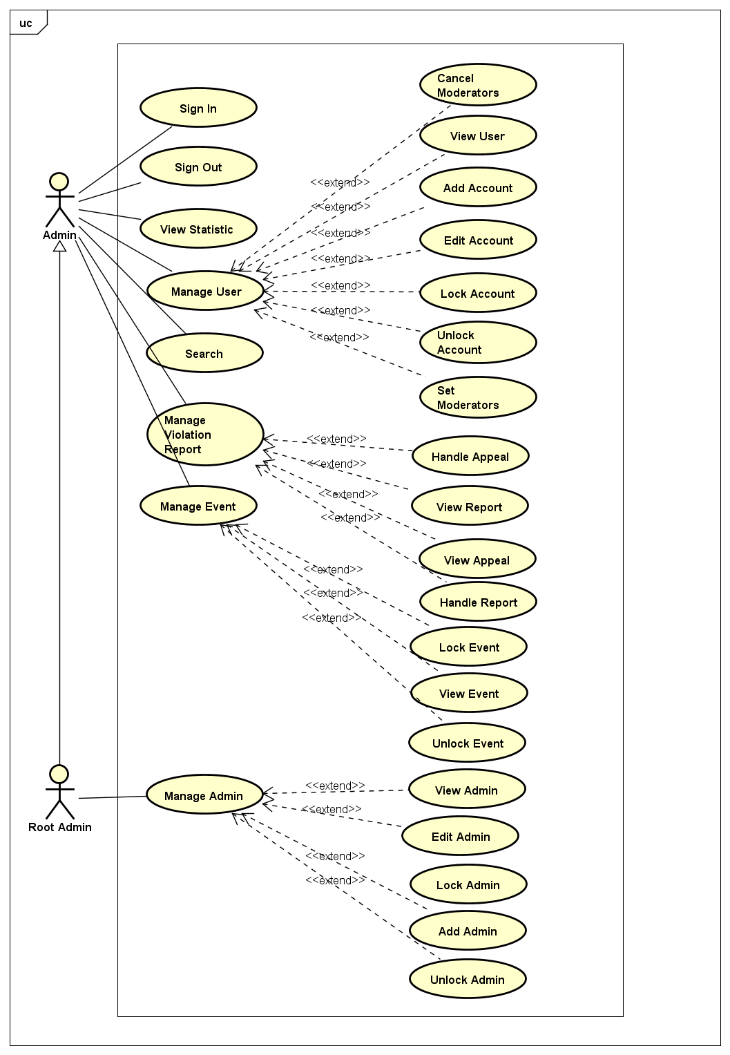

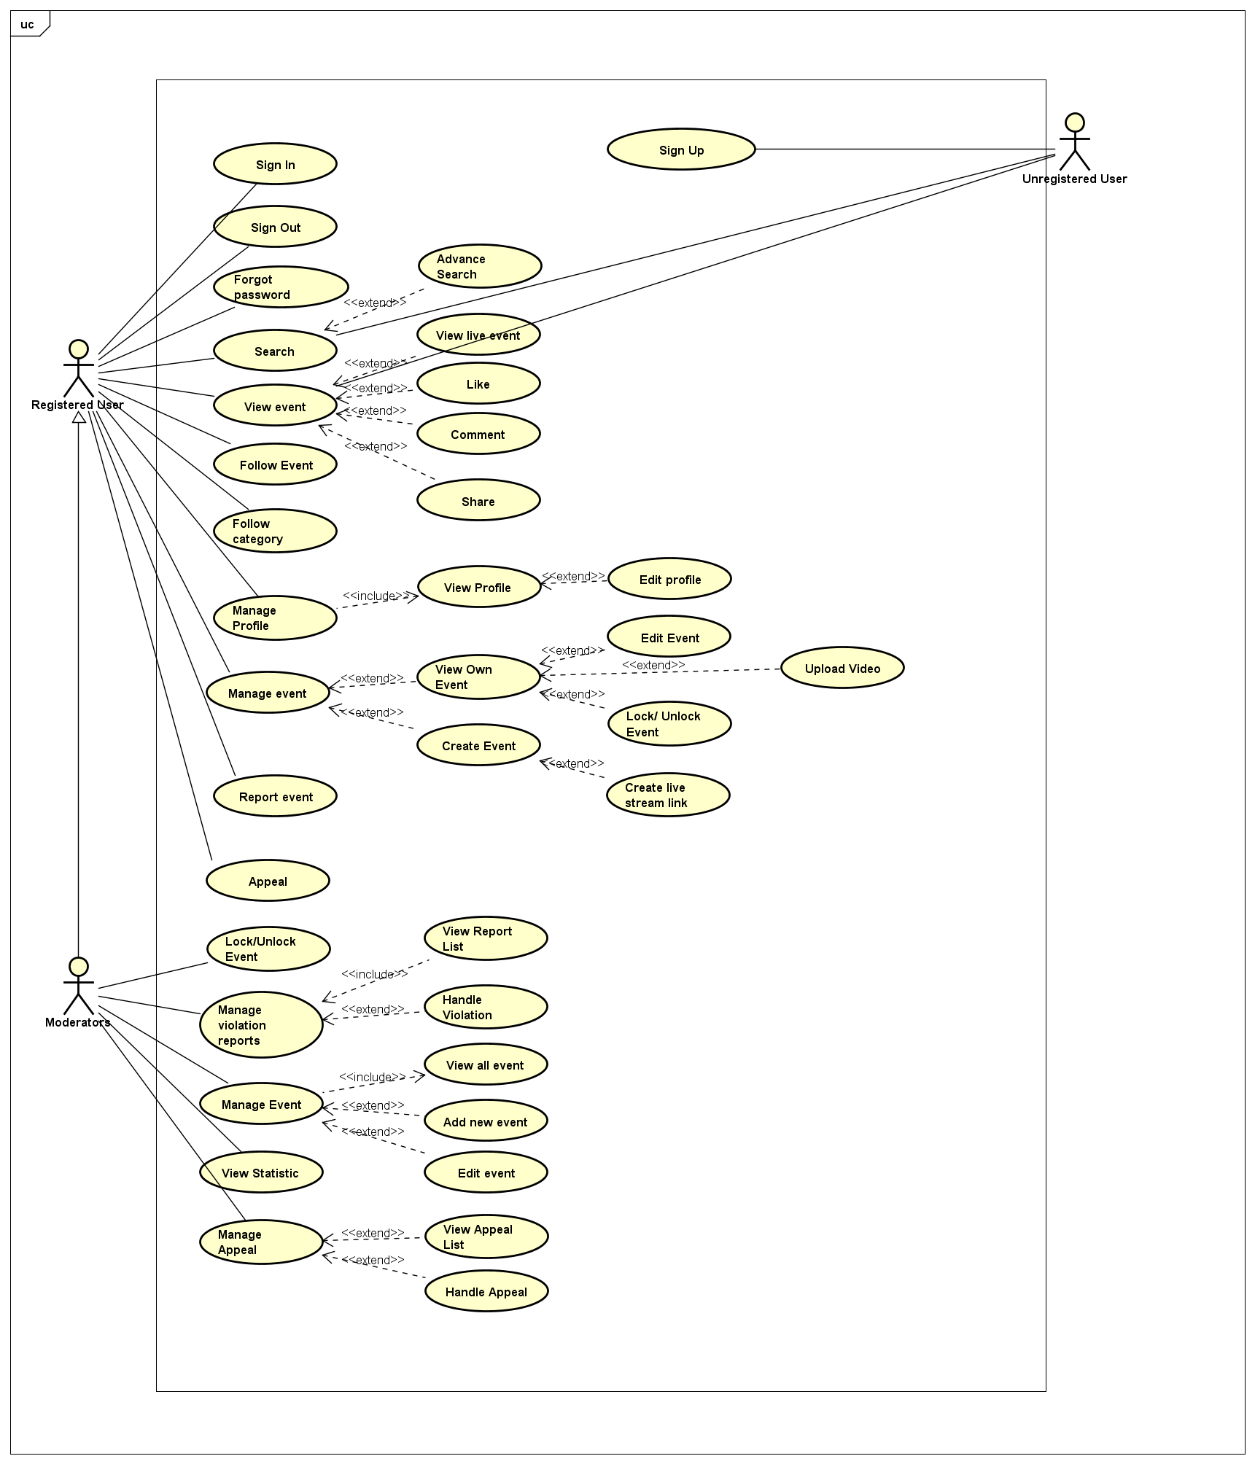

### User Functions

#### UC-001: Sign In

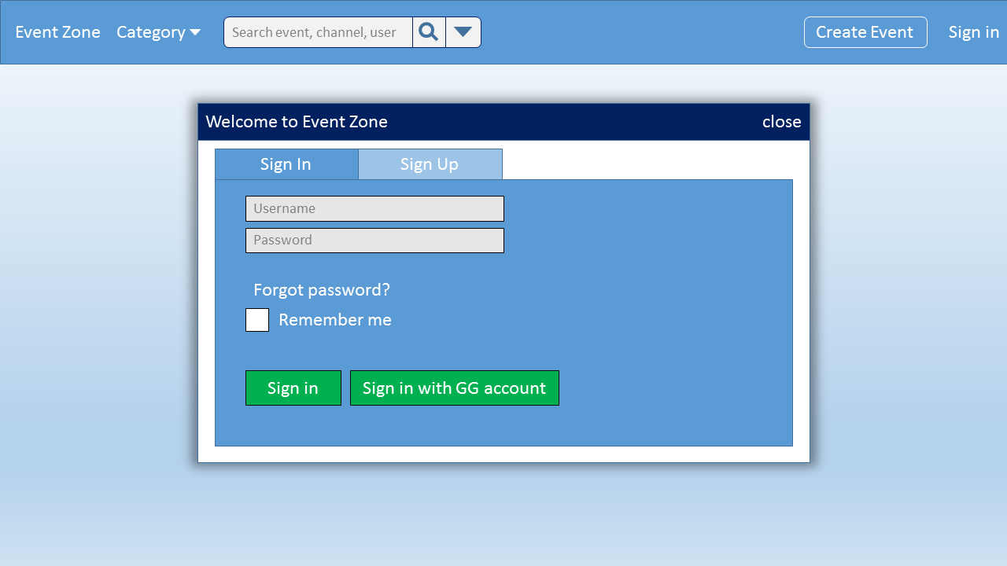

Figure 1 Sign In

|  |  |  |  |  |  |
| --- | --- | --- | --- | --- | --- |
| Use Case Name | Sign in | | | | |
| Use Case ID | UC-001 | | | | |
| Created By | HaNS02665 | | Last Updated By | | HaNS02665 |
| Date Created | 21/9/2015 | | Date Last Updated | | 29/9/2015 |
| Actor | Registed User,Moderators | | | | |
| Goal/Description | Allow user can sign in to the system | | | | |
| Pre-Condition | User has registered account | | | | |
| Trigger | User wants to sign in to system | | | | |
| Basic Path | Actor’s Action | | | System response | |
|  | 1. Click on “Sign in /Sign up” button | | | Display”Sign in,Sign up” popup | |
|  | 1. Enter email and password   *There is an alternative path : A1*  *There are exception paths E1,E2* | | |  | |
| 1. Check on or no “Keep me signed in” checkbox | | |  | |
| 1. Click on”Sign in” button   *There is a exception paths E3* | | | Redirect to Main Screen and display“Welcome,user’name!” | |
| Alternative Paths | A1 | Actor’s Action | | System response | |
| 2. Click on “Sign in with google account” button  *There is an exception path :E4* | | Redirect to choose user’s account google Screen | |
| 3. Choose user’s acount google+ | | System will display “User’s login is successfull” message. | |
| Post Condition | If basic path is successful system redirect Redirect to the Main Screen and display user’s name in header.  If exception are thrown, the result must match with output of each described exception. | | | | |
| Exception Paths | E1 | Actor’s Action | | System response | |
| If email textbox is null | | Screen with show the notice “Email cannot empty” and return to step 2 of basic path | |
| If Password textbox is null | | Screen with show the notice “Password cannot empty” and return to step 2 of basic path | |
| If the Email and Password texbox are null | | Screen with show the notice “Email cannot empty” and return to step 2 of basic path | |
| E2 | If user forget password; user click on “Forget Password?” | | screen with show the popup request user fill user’s email to reset password | |
| E3 | If user enter the wrong Email address | | Screen with show the notice “Email address is invalid” and return to step 2 of basic path | |
| If user enter the wrong Password | | Screen with show the notice “Password is incorrect. Please try again”and return to step 2 of basic path | |
| E4 | If user click on “Login with google account” the first time. | | the screen will change choose user’s account google Screen then after user click “Accept” button, the screen will change “Register Account” Screen | |
| E5 |  | |  | |
| Notes |  | | | | |

#### UC-002: Sign Out

|  |  |  |  |  |
| --- | --- | --- | --- | --- |
| Use Case Name | Sign Out | | | |
| Use Case ID | UC-002 | | | |
| Created By | HaNS02665 | Last Updated By | | HaNS02665 |
| Date Created | 21/9/2015 | Date Last Updated | | 29/9/2015 |
| Actor | Registered User,Moderators | | | |
| Goal/Description | Allow user can sign out of system | | | |
| Pre-Condition | Users were signed in to system | | | |
| Trigger | User wants to sign out of system | | | |
| Basic Path | Actor’s Action | | System response | |
|  | 1. Mouse moves on “Account” button on every screen that user want | | Display manage account Dropdown list | |
|  | 1. Click on “Sign out” button | | Redirect to the “Home”Screen | |
| Alternative Paths |  | | | |
| Post Condition | System redirect to Main screen. | | | |
| Exception Paths |  | | | |
| Notes |  | | | |

#### UC-003: Sign Up

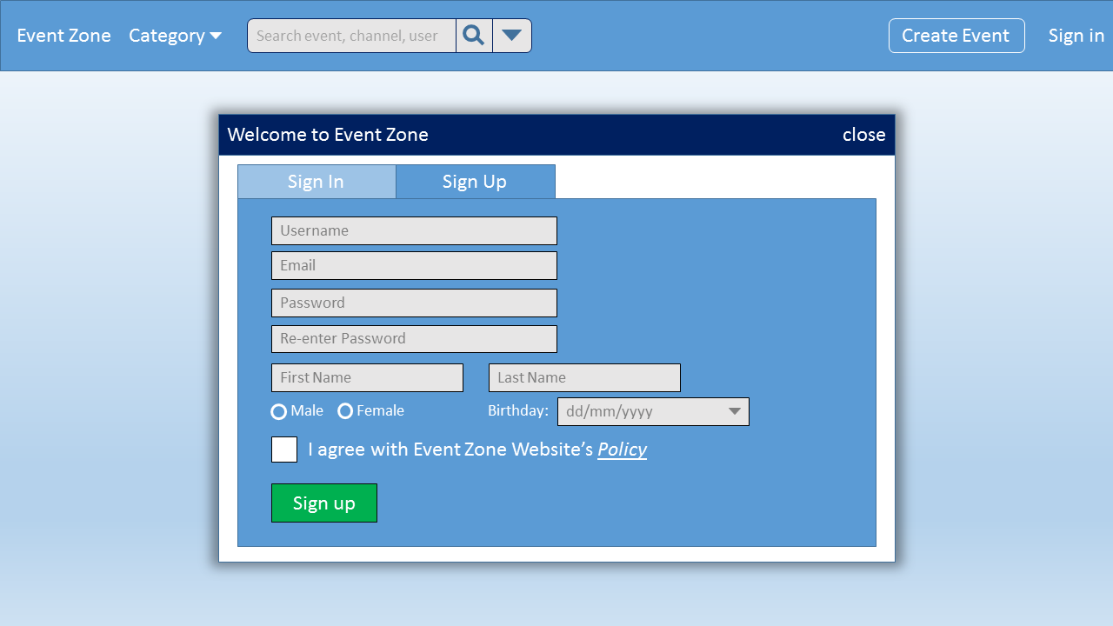

Figure 2 Sign Up

|  |  |  |  |  |  |
| --- | --- | --- | --- | --- | --- |
| Use Case Name | Sign Up | | | | |
| Use Case ID | UC-003 | | | | |
| Created By | HaNS02665 | | Last Updated By | | HaNS02665 |
| Date Created | 21/9/2015 | | Date Last Updated | | 29/9/2015 |
| Actor | Unregisted User | | | | |
| Goal/Description | Allow users can sign up account for login to system | | | | |
| Pre-Condition | System is in “Sign in/Sign up” Screen | | | | |
| Trigger | User wants to sign up account to sign in system | | | | |
| Basic Path | Actor’s Action | | | System response | |
|  | 1. Click “Sign up” label link | | | Redirect to “Sign up” Screen | |
| 1. Fill all infomation of user   *There is an exception: E1* | | |  | |
| 1. Click on ”I have read and accepted with Event Zone Website’s policy” button | | |  | |
| 1. Click “Register” button | | | Display “Your account has been registed successfully” popup | |
| Alternative Paths |  | | | | |
| Post Condition | If basic path is successful, User’account is registed successful.. System redirect to “Sign in/Sign up” Screen.  If exception are thrown, the result must match with output of each described exception. | | | | |
| Exception Paths | E1 | Actor’s Action | | System response | |
| If username texbox is null | | Screen will show the notice “Please enter your username” and return to step 2 of basic path | |
| If user enter the username that same with username was already by another user in website system | | Screeen with show “your username are already by another user before.Please try again with new usename! ” and return to step 2 of basic path | |
| If password box is blank | | Screen will show the notice “Please enter your password” and return to step 2 of basic path | |
| If re-enter password texbox is null | | Screen will show the notice “Please re-enter your password” and return to step 2 of basic path | |
| If user re-enter password that not matched with the password above | | Screen will show the notice “Password does not match the confirm password” and return to step 2 of basic path | |
| If email address texbox is null | | the screen will show the notice “You did not enter your email” and return to step 2 of basic path | |
| If user enter wrong format of email address | | the screen will show the notice “The email’s format is incorrect” and return to step 2 of basic path | |
| If user enters username less than 8 characters | | the screen will show the notice " The username must more than 8 characters " and return to step 2 of basic path | |
| If user enters password less than 8 characters | | the screen will show the notice " The password must more than 8 characters " and return to step 2 of basic path | |
| Notes |  | | | | |

#### UC-004: Forgot Password

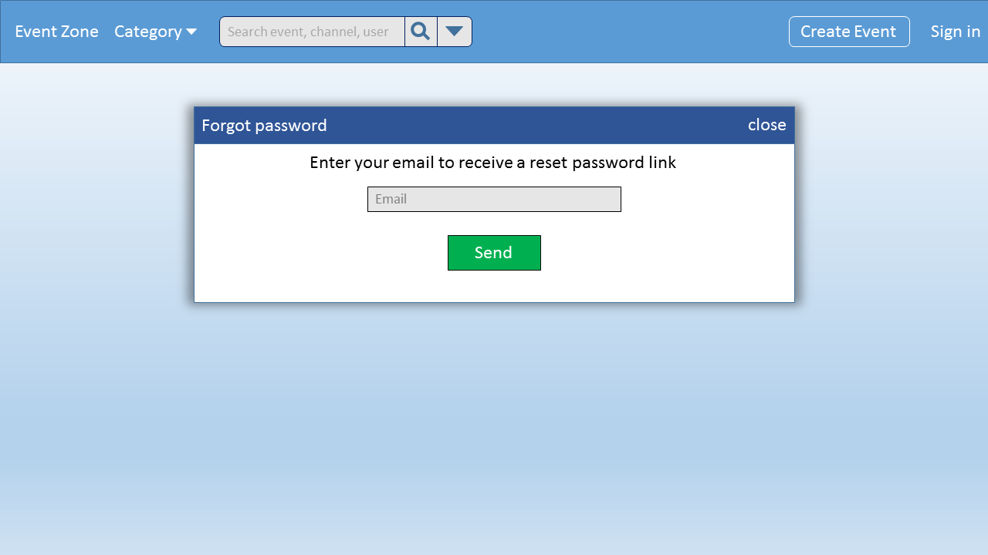

Figure 3 Forgot Password

|  |  |  |  |  |  |
| --- | --- | --- | --- | --- | --- |
| Use Case Name | Forgot Password | | | | |
| Use Case ID | UC-004 | | | | |
| Created By | HaNS02665 | | Last Updated By | | HaNS02665 |
| Date Created | 21/9/2015 | | Date Last Updated | | 29/9/2015 |
| Actor | Registed User,Moderators | | | | |
| Goal/Description | Allow users can reset user’password | | | | |
| Pre-Condition | System is in “Sign in” Screen | | | | |
| Trigger | User wants to find user’password to login system | | | | |
| Basic Path | Actor’s Action | | | System response | |
| 1. Click “Forgot your Password?” label link | | | Display “Find your account”popup | |
| 1. Fill user’s email information on textfiled   *There are exception paths E1,E2* | | |  | |
| 1. Click “Send”button | | | System will display a message: “An email has been sent a link to reset your password” | |
| Alternative Paths |  | | |  | |
| Post Condition | If basic path is successful, system sent to user’s email “reset password” link and system redirect to “Sign in” Screen.  If exception are thrown, the result must match with output of each described exception. | | | | |
| Exception Paths |  | Actor’s Action | | System response | |
| E2 | If user enter wrong format of email | | Screen show the notice “The email’s format is incorrect”message and return to step 2 of basic path | |
| If user did not enter the email address in the textfiled | | Screen show the notice “Please enter your email address!” message and return to step 2 of basic path | |
| Notes |  | | | | |

#### View Event

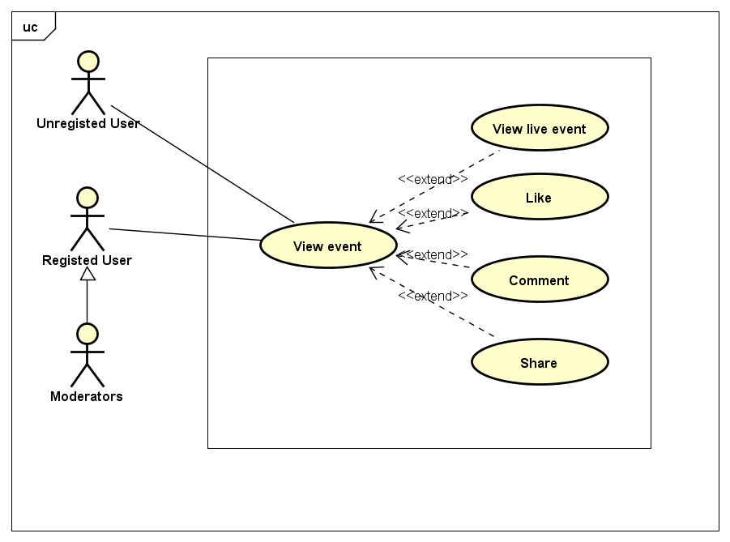

##### UC-005: View Event

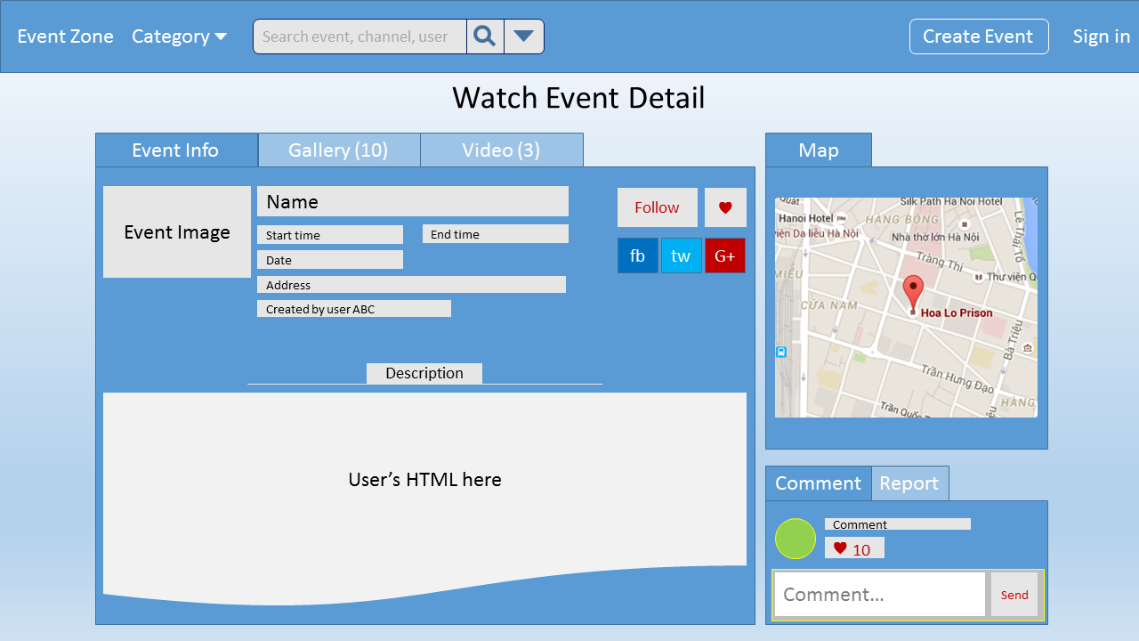

Figure 4 View Event

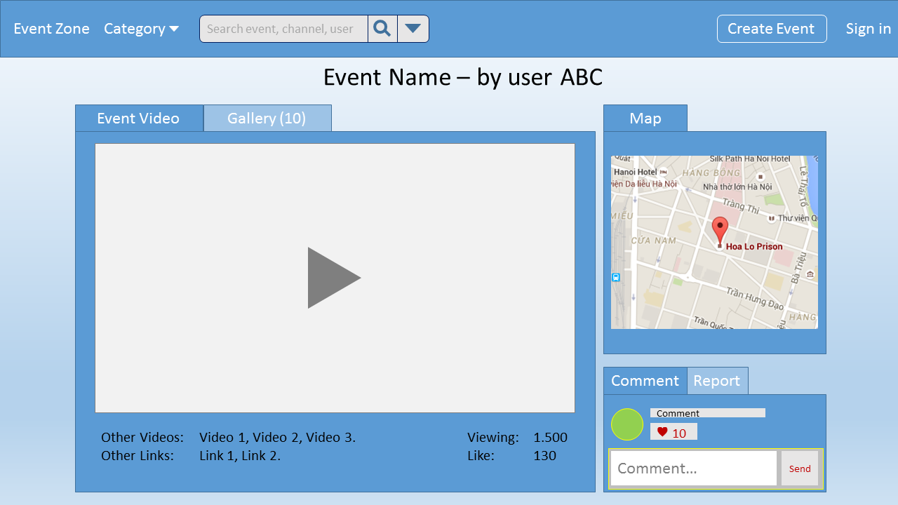

Figure 5 View Video

|  |  |  |  |  |  |  |
| --- | --- | --- | --- | --- | --- | --- |
| Use Case Name | View Event | | | | | |
| Use Case ID | UC-005 | | | | | |
| Created By | HaNS02665 | | Last Updated By | | | HaNS02665 |
| Date Created | 21/9/2015 | | Date Last Updated | | | 29/9/2015 |
| Actor | Unregisted User,Registed User,Moderators | | | | | |
| Goal/Description | Allow users view event’s information screen | | | | | |
| Pre-Condition | System is in “Main Screen” | | | | | |
| Trigger | Users want to view any event on website | | | | | |
| Basic Path | Actor’s Action | | | System response | | |
|  | 1. Click a single event on Video List Screen on MainScreen/ View Channel/Few Detail/Manage Channel/Manage Event   *There is an exception path :E1* | | | Redirect to the event screen that contain the chosen fact information | | |
| Alternative Paths |  | | |  | | |
| Post Condition | If basic path is successful, View event Screen is displaying.  If exception are thrown, the result must match with output of each described exception. | | | | | |
| Exception Paths | E1 | Actor’s Action | | | System response | |
| 1. Select “Back” button | | | Redirect to Event List Screen | |
| Notes |  | | | | | |

##### UC-006: View Live Event

|  |  |  |  |  |  |  |
| --- | --- | --- | --- | --- | --- | --- |
| Use Case Name | View Live Event | | | | | |
| Use Case ID | UC-006 | | | | | |
| Created By | HaNS02665 | | Last Updated By | | | HaNS02665 |
| Date Created | 23/9/2015 | | Date Last Updated | | | 29/9/2015 |
| Actor | Unregisted User,Registed User,Moderators | | | | | |
| Goal/Description | Allow users view live event’s information screen | | | | | |
| Pre-Condition | System is in “View Event” Screen | | | | | |
| Trigger | User wants to view any live event on website. | | | | | |
| Basic Path | Actor’s Action | | | System response | | |
|  | 1. Click a single live event on Live Event List Screen   *There is an exception path: E1* | | | Redirect to the event screen that contain the chosen fact information | | |
| Alternative Paths |  | | |  | | |
| Post Condition | If basic path is successful, View Live Event Screen is displaying.  If exception are thrown, the result must match with output of each described exception. | | | | | |
| Exception Paths | E1 | Actor’s Action | | | System response | |
| 1. Select “Back” button | | | Redirect to Live Event List Screen | |
| Notes |  | | | | | |

##### UC-007: Like

|  |  |  |  |  |
| --- | --- | --- | --- | --- |
| Use Case Name | Like Event | | | |
| Use Case ID | UC-007 | | | |
| Created By | HaNS02665 | Last Updated By | | HaNS02665 |
| Date Created | 21/9/2015 | Date Last Updated | | 29/9/2015 |
| Actor | Registed User,Moderators | | | |
| Goal/Description | Allow users to like to event | | | |
| Pre-Condition | System is in “View Event” screeen | | | |
| Trigger | User wants to “like” any event on website | | | |
| Basic Path | Actor’s Action | | System response | |
|  | 1. Click on “Like” tab | | Display the number of like will increase with once | |
| Alternative Paths |  | |  | |
| Post Condition | If basic path is successful ,system is in “View Event” screen and the number of like will increase with once | | | |
| Exception Paths |  | | | |
| Notes |  | | | |

##### UC-008: Share Event

|  |  |  |  |  |  |  |
| --- | --- | --- | --- | --- | --- | --- |
| Use Case Name | Share Event | | | | | |
| Use Case ID | UC-008 | | | | | |
| Created By | HaNS02665 | | Last Updated By | | | HaNS02665 |
| Date Created | 29/9/2015 | | Date Last Updated | | | 29/9/2015 |
| Actor | Registed User,Moderators | | | | | |
| Goal/Description | Allow users to share event | | | | | |
| Pre-Condition | System is in “View Event” screeen | | | | | |
| Trigger | Users want to share any event on website | | | | | |
| Basic Path | Actor’s Action | | | System response | | |
|  | 1. Click on “Facebook” or “Google+” or “Twitter” button share | | | Redirect to “Share this event” popup screen | | |
|  | 1. Input the status’s content on textbox.   *There is an exception path: E1* | | |  | | |
|  | 1. Click on “Share Link” button | | | Display “Event is shared sucessfull” message | | |
| Alternative Paths |  | | | | | |
| Post Condition | If basic path is successful ,View event Screen is displaying and the number of share will increase with once.  If exception are thrown, the result must match with output of each described exception. | | | | | |
| Exception Paths | E1 | Actor’s Action | | | System response | |
|  | 1. Click on “Cancel” button | | | System is in “View Event” screeen and “Share this event” popup is closed | |
| Notes |  | | | | | |

##### UC-009: Comment

|  |  |  |  |  |
| --- | --- | --- | --- | --- |
| Use Case Name | Comment | | | |
| Use Case ID | UC-009 | | | |
| Created By | HaNS02665 | Last Updated By | | HaNS02665 |
| Date Created | 23/9/2015 | Date Last Updated | | 29/9/2015 |
| Actor | Registed User,Moderators | | | |
| Goal/Description | Allow users to comment to event | | | |
| Pre-Condition | System is in “View Event” screeen | | | |
| Trigger | User wants to “comment” any event on website | | | |
| Basic Path | Actor’s Action | | System response | |
|  | 1. Click on “Comment” tab | |  | |
| 1. Input user’s comment | |  | |
|  | 1. Click “Send” button | | Update user’comment in the chat box | |
| Alternative Paths |  | | | |
| Post Condition | If basic path is successful ,system is in “View Event” screen and user’s comment is sent sucessful | | | |
| Exception Paths |  | | | |
| Notes |  | | | |

#### Search

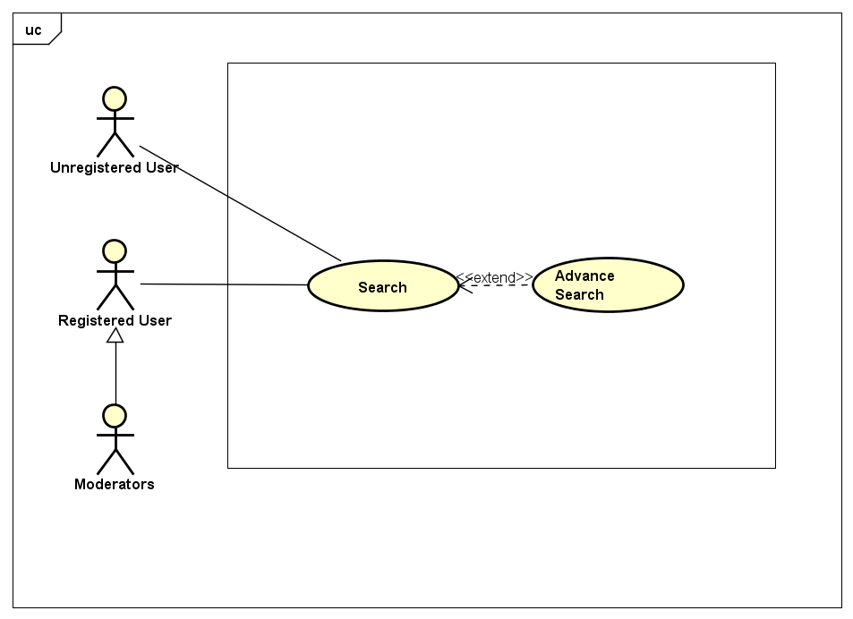

##### UC-010: Search

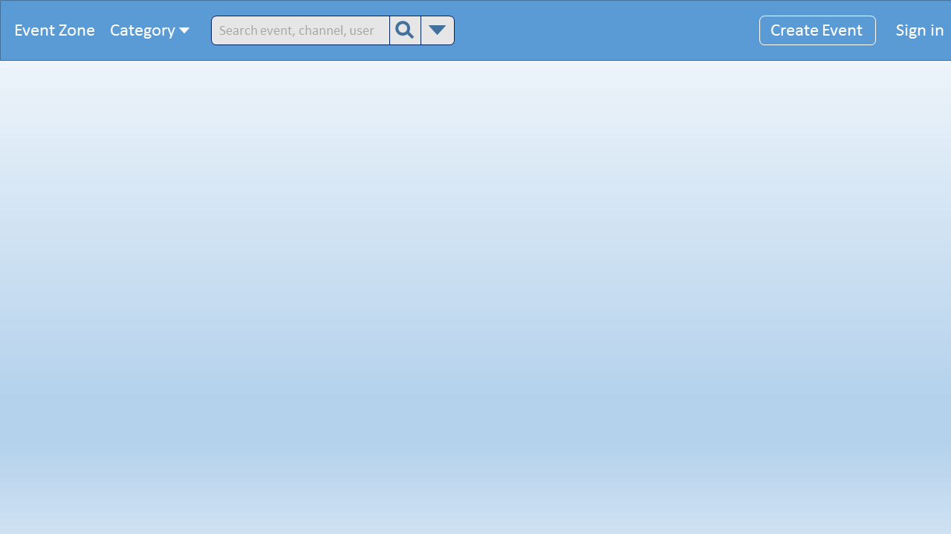

Figure 6 Search

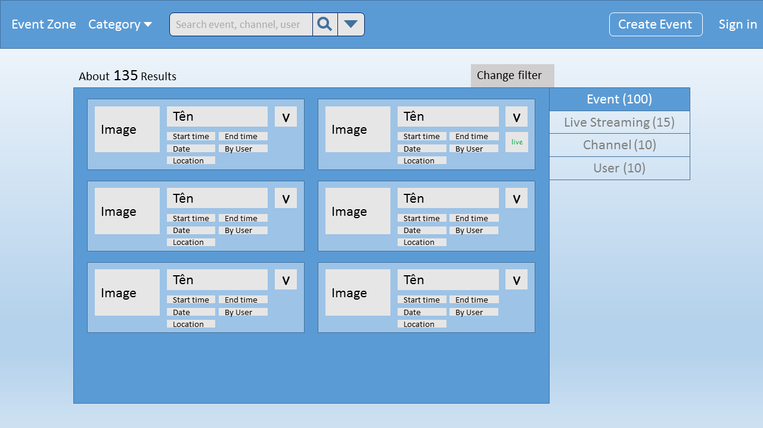

Figure 7 Result Page

|  |  |  |  |  |  |
| --- | --- | --- | --- | --- | --- |
| Use Case Name | Search | | | | |
| Use Case ID | UC-010 | | | | |
| Created By | ANHDTL | | **Last Updated By** | | ANHDTL |
| Date Created | 21/09/2015 | | **Date Last Updated** | | 01/10/2015 |
| Actor | Registed User, Unregisted User, Moderator | | | | |
| Goal/Description | Allow User find out the event and channel which match the inputed text. | | | | |
| Pre-Condition | User is accessed to the Event Zone website. | | | | |
| Trigger | User navigates to the search bar. | | | | |
|  | Actor’s Action | | | System’s Response | |
| Basic Path | 1. Input text to the search bar | | | Show event and channel suggestions below the search text field while User is typing. | |
| 2. Choose once of suggestions.  *There is an alternative path : A1* | | | Display suggestions text on the search bar. | |
| 3. Click on “search” button.  *T**here is an alternative path : A2*  *There is an exception: E1* | | | Redirect to Result screen. | |
| Alternative Path | A1 | 2. Search by type keywords without choose a suggestion. | | Come back to step 3. | |
| A2 | 3. Press “Enter” keyboard while mouse still focus on search bar. | | Redirect to Result screen. | |
| Exception Paths | E1 | 3. If search bar is empty. | | Show the notice: “You must input keywords to search!” | |
| Post Condition | User is staying on Result screen which has all matching search results. | | | | |
| Notes |  | | | | |

##### UC-011: Advance Search

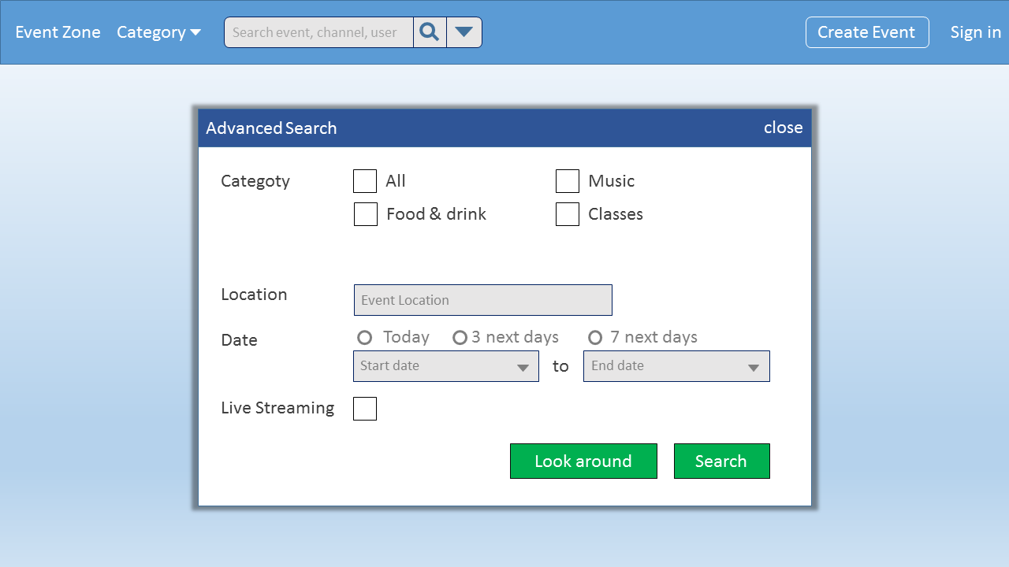

Figure 8 Advance Search

|  |  |  |  |  |  |
| --- | --- | --- | --- | --- | --- |
| Use Case Name | Advance Search | | | | |
| Use Case ID | UC-011 | | | | |
| Created By | ANHDTL | | **Last Updated By** | | ANHDTL |
| Date Created | 21/09/2015 | | **Date Last Updated** | | 01/10/2015 |
| Actor | Registered User, Unregistered User, Moderator | | | | |
| Goal/Description | Allow User combine some search conditions to get the best result. | | | | |
| Pre-Condition | User is accessed to the Event Zone website. | | | | |
| Trigger | User navigates to the Advantage Search. | | | | |
|  | Actor’s Action | | | System’s Response | |
| Basic Path | 1. Click on the “Advantage search” button | | | Show the “Advantage search” popup | |
| 2. Select on searching conditions checkbox and fill information which User want. | | |  | |
| 3. Click on “Search” button | | | Redirect to Result screen | |
| Alternative Path |  |  | |  | |
| Exception Paths | E | In all step: User click “cancel” button. | | Disappear a advance search popup. | |
| Post Condition | User is staying on Result screen which has all matching search results. | | | | |
| Notes |  | | | | |

#### UC-012: Follow Event

|  |  |  |  |  |  |
| --- | --- | --- | --- | --- | --- |
| Use Case Name | Follow Event | | | | |
| Use Case ID | UC-012 | | | | |
| Created By | ANHDTL | | **Last Updated By** | | ANHDTL |
| Date Created | 21/09/2015 | | **Date Last Updated** | | 01/10/2015 |
| Actor | Registered User, Moderator | | | | |
| Goal/Description | Allow User to follow the event to easy to get notification about them. | | | | |
| Pre-Condition | User is staying on “View Event” or “Few Detail” screens. And User is not follow these. | | | | |
| Trigger | User navigates to Follow others. | | | | |
|  | Actor’s Action | | | System’s Response | |
| Basic Path | 1. Click on the “Follow” button | | | “Follow” button will be change to “Followed” button. | |
| Alternative Path |  |  | |  | |
| Exception Paths |  |  | |  | |
| Post Condition | User still staying on “View Event” or “Few Detail” screens. | | | | |
| Notes |  | | | | |

#### UC-013: Unfollow Event

|  |  |  |  |  |  |
| --- | --- | --- | --- | --- | --- |
| Use Case Name | Unfollow Event | | | | |
| Use Case ID | UC-013 | | | | |
| Created By | ANHDTL | | **Last Updated By** | | ANHDTL |
| Date Created | 21/09/2015 | | **Date Last Updated** | | 01/10/2015 |
| Actor | Registered User, Moderator | | | | |
| Goal/Description | Allow User unfollow the event. | | | | |
| Pre-Condition | User is staying on “View Event” or “Few Detail” screens. And User has already followed. | | | | |
| Trigger | User navigates to Unfollow others. | | | | |
|  | Actor’s Action | | | System’s Response | |
| Basic Path | 1. Click on the “Unfollow” button | | | “Followed” button will be change to “Follow” button. | |
| Alternative Path |  |  | |  | |
| Exception Paths |  |  | |  | |
| Post Condition | User still staying on “View Event” or “Few Detail” screens. | | | | |
| Notes |  | | | | |

#### UC-014: Follow Category

|  |  |  |  |  |  |  |
| --- | --- | --- | --- | --- | --- | --- |
| Use Case Name | | Follow Category | | | | |
| Use Case ID | UC-014 | | | | | |
| Created By | ANHDTL | | | **Last Updated By** | | ANHDTL |
| Date Created | 21/09/2015 | | | **Date Last Updated** | | 01/10/2015 |
| Actor | Registered User, Moderator | | | | | |
| Goal/Description | Allow User follow the category to easy to see a group of related event. | | | | | |
| Pre-Condition | User is staying on Main screen. And User didn’t follow that category. | | | | | |
| Trigger | User navigates to Follow Category. | | | | | |
|  | Actor’s Action | | | | System’s Response | |
| Basic Path | 1. Mouse hover on any “Category” button | | | | Show a box include a “Follow” button and some statistic. | |
| 2. Click on “Follow” button.  *There is an exception: E1* | | | | Change “Follow” button to “Followed” button. | |
| Alternative Path |  | |  | |  | |
| Exception Paths | E1 | | In all step: Mouse move to outside the box and “Category” button. | | Disappear the box. | |
| Post Condition | User still staying on Main screen. User is following category. | | | | | |
| Notes |  | | | | | |

#### UC-015: Unfollow Category

|  |  |  |  |  |  |  |
| --- | --- | --- | --- | --- | --- | --- |
| Use Case Name | | Unfollow Category | | | | |
| Use Case ID | UC-015 | | | | | |
| Created By | ANHDTL | | | **Last Updated By** | | ANHDTL |
| Date Created | 21/09/2015 | | | **Date Last Updated** | | 01/10/2015 |
| Actor | Registered User, Moderator | | | | | |
| Goal/Description | Allow User unfollow the category. | | | | | |
| Pre-Condition | User is staying on Main screen. And User has followed that category. | | | | | |
| Trigger | User navigates to Unfollow Category. | | | | | |
|  | Actor’s Action | | | | System’s Response | |
| Basic Path | 1. Mouse hover on any “Category” button | | | | Show a box include a “Unfollow” button and some statistic. | |
| 2. Click on “Unfollow” button.  *There is an exception: E1* | | | | Change “Followed” button to “Follow” button. | |
| Alternative Path |  | |  | |  | |
| Exception Paths | E1 | | In all step: Mouse move to outside the box and “Category” button. | | Disappear the box. | |
| Post Condition | User still staying on Main screen. User is not following category. | | | | | |
| Notes |  | | | | | |

#### Manage Profile

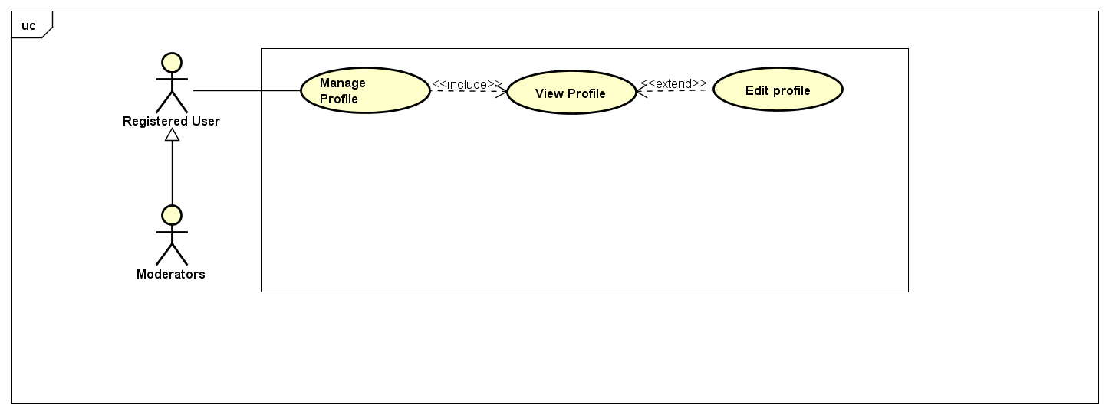

##### UC-016: View Profile

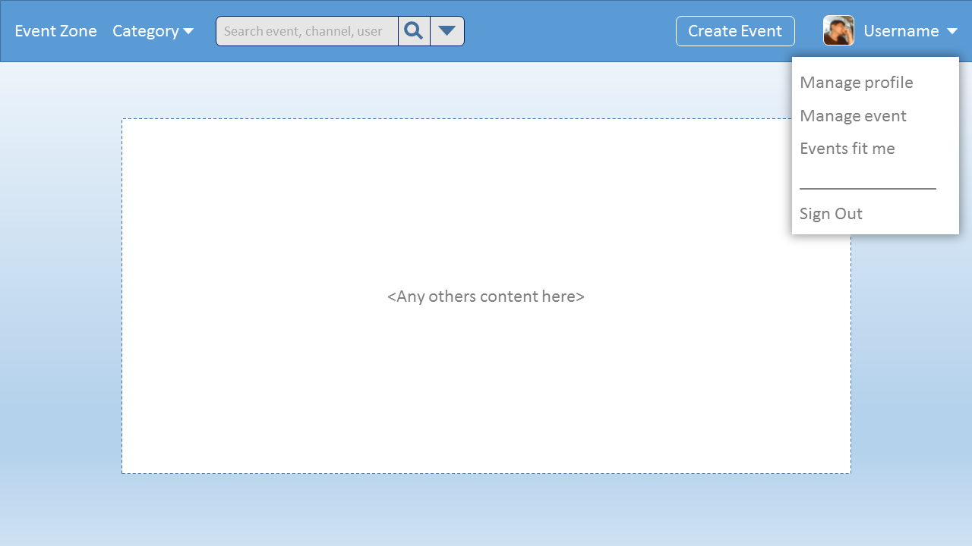

Figure 9 Manage Profile

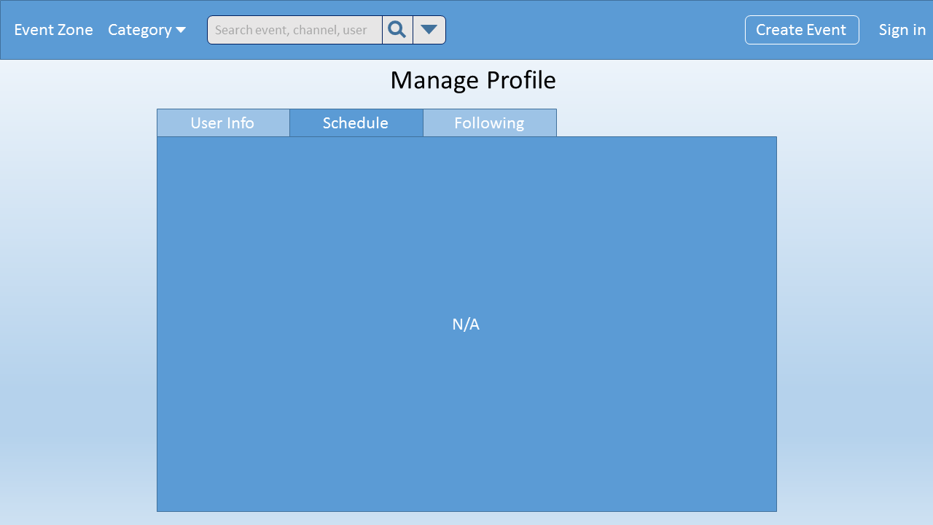

Figure 10 View Schedule

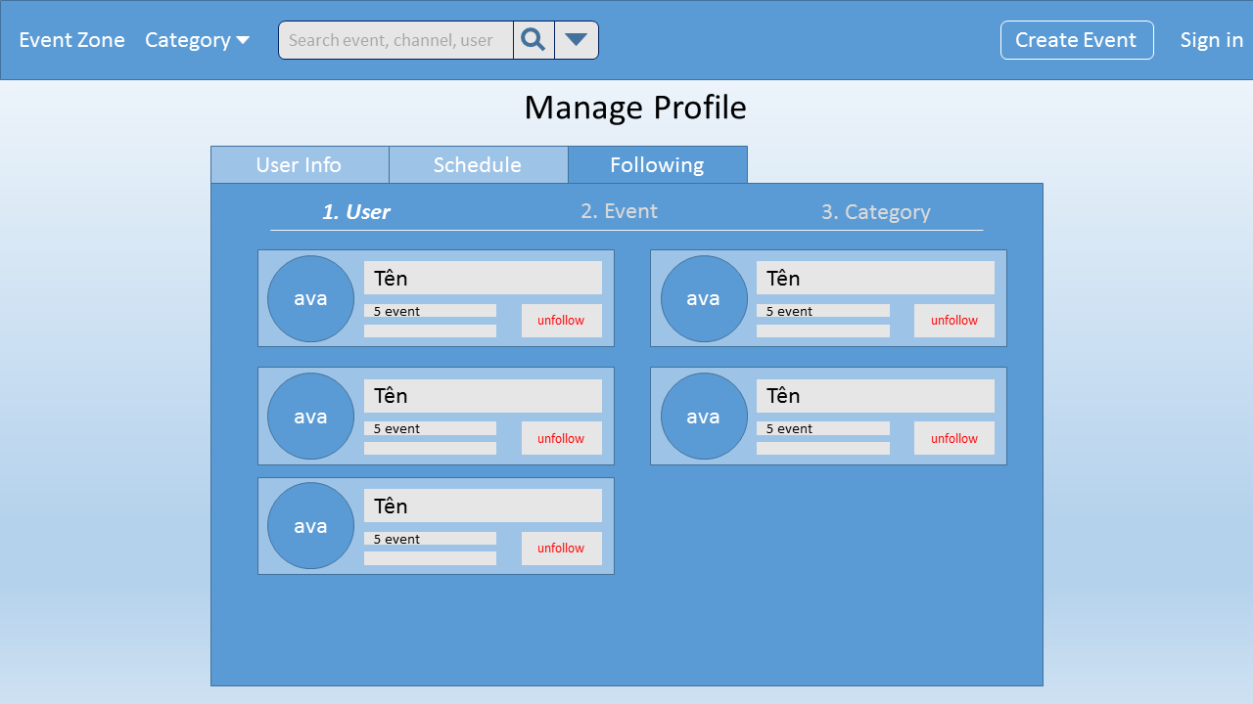

Figure 11 View Following

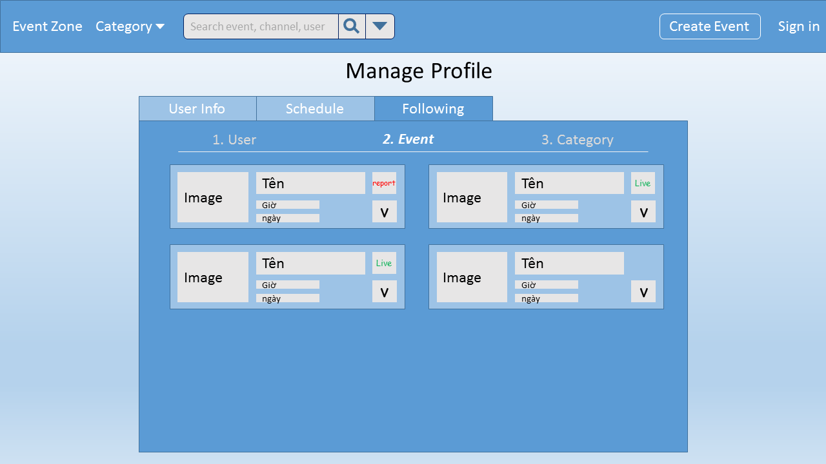

Figure 12 View Following Event

|  |  |  |  |  |  |
| --- | --- | --- | --- | --- | --- |
| Use Case Name | View Profile | | | | |
| Use Case ID | UC-016 | | | | |
| Created By | ANHDTL | | **Last Updated By** | | ANHDTL |
| Date Created | 21/09/2015 | | **Date Last Updated** | | 01/10/2015 |
| Actor | Registered User, Moderator | | | | |
| Goal/Description | Allow user to redirect to manage user information | | | | |
| Pre-Condition | User is staying on any screen of EventZone website. | | | | |
| Trigger | User navigates to view profile. | | | | |
|  | Actor’s Action | | | System’s Response | |
| Basic Path | 1. Click on avatar button | | | Redirect to the “Manage profile” screen. | |
| Alternative Path |  |  | |  | |
| Exception Paths |  |  | |  | |
| Post Condition | User is staying in “Manage Profile” screen. | | | | |
| Notes | “User Info” is a default tab of Manage profile screen. User can view all account information in “User Info” tab. | | | | |

##### UC-017: Edit Profile

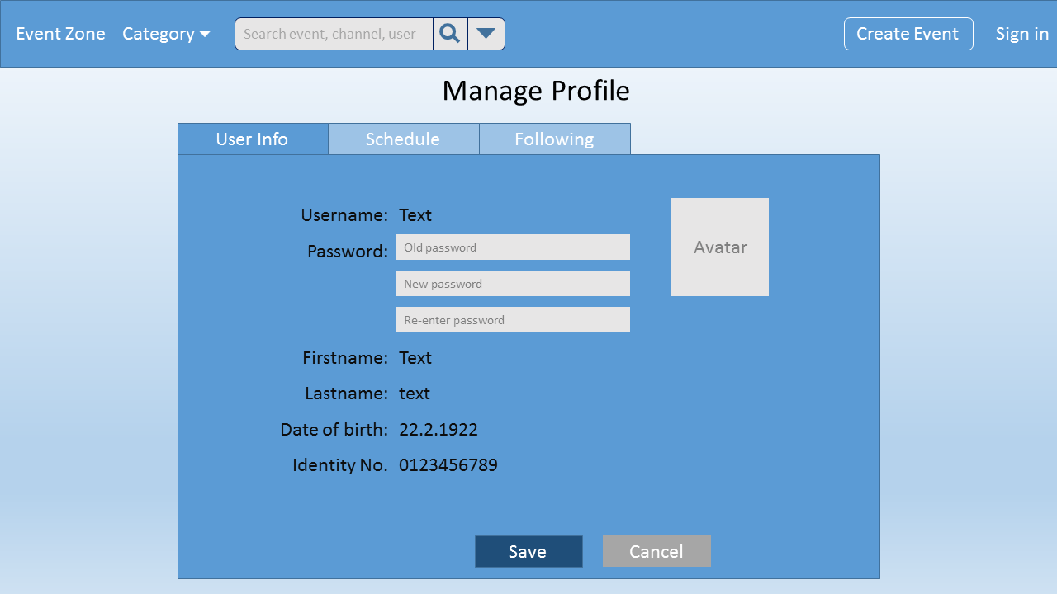

Figure 13 Edit Password

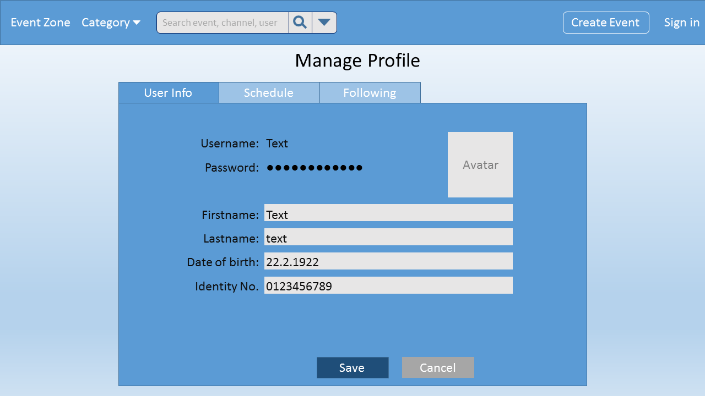

Figure 14 Edit Info

|  |  |  |  |  |  |  |
| --- | --- | --- | --- | --- | --- | --- |
| Use Case Name | | Edit Profile | | | | |
| Use Case ID | UC-017 | | | | | |
| Created By | ANHDTL | | | **Last Updated By** | | ANHDTL |
| Date Created | 21/09/2015 | | | **Date Last Updated** | | 01/10/2015 |
| Actor | Registered User, Moderator | | | | | |
| Goal/Description | System allows User to edit profile’s information. | | | | | |
| Pre-Condition | User is staying on“User Info” tab of Manage Profile screen. | | | | | |
| Trigger | User navigates to edit and update profile. | | | | | |
|  | Actor’s Action | | | | System’s Response | |
| Basic Path | 1. Click on “Edit” button. | | | | “Edit” button will change to “Save” button and “Cancel” button will appear. | |
| 2. User fill or edit information. | | | |  | |
| 3. Click on “Save” button. | | | | “Save” button will change to “Edit” button and “Cancel” button will disappear. | |
| Alternative Path |  | |  | |  | |
| Exception Paths | E | | All Step: Click on “Cancel” button. | | Return to initial “User Info” tab. | |
| Post Condition | User is staying on “User Info” tab of Manage Profile screen. | | | | | |
| Notes | “User Info” is a default tab of Manage profile screen. | | | | | |

#### UC-018: Report Event

|  |  |  |  |  |  |
| --- | --- | --- | --- | --- | --- |
| Use Case Name | Report Event | | | | |
| Use Case ID | UC-018 | | | | |
| Created By | ANHDTL | | **Last Updated By** | | ANHDTL |
| Date Created | 21/09/2015 | | **Date Last Updated** | | 01/10/2015 |
| Actor | Registered User, Moderator | | | | |
| Goal/Description | System allows User to report other’s event. | | | | |
| Pre-Condition | User is staying on “View Event” screen. | | | | |
| Trigger | User navigates to report other’s event. | | | | |
|  | Actor’s Action | | | System’s Response | |
| Basic Path | 1. Click on “Report” tab | | | Display the report tab include provided reason . | |
| 2.1. Select reasons | | |  | |
| 3. Click on “Report” button. | | | “Report” button will be disabled. And show a notice “Submited successfully”. | |
| Alternative Path |  |  | |  | |
| Exception Paths | E | In all Step: Click on others tab or others screens. | | Automatic cancel report action. And redirect follow User’s navigation. | |
| Post Condition | User is staying in “View Event” screen | | | | |
| Notes |  | | | | |

#### UC-019: Appeal

|  |  |  |  |  |  |
| --- | --- | --- | --- | --- | --- |
| Use Case Name | Appeal | | | | |
| Use Case ID | UC-019 | | | | |
| Created By | ANHDTL | | **Last Updated By** | | ANHDTL |
| Date Created | 21/09/2015 | | **Date Last Updated** | | 01/10/2015 |
| Actor | Registered User, Moderator | | | | |
| Goal/Description | Allow User appeal other’s report. | | | | |
| Pre-Condition | User is staying on “Manage Event” tab of Manage Channel screen. | | | | |
| Trigger | User navigates to appeal other’s report. | | | | |
|  | Actor’s Action | | | System’s Response | |
| Basic Path | 1. Click on “Appeal” button beside event’s thumbnail, which be reported. | | | Display the “Appeal” popup. | |
| 2. Fill the appeal reason for each report. | | |  | |
| 3. Click on “Done” button. | | | Display “Manage Event” tab. | |
| Alternative Path |  |  | |  | |
| Exception Paths |  |  | |  | |
| Post Condition | User is staying on “Manage Event” tab of Manage Channel screen. | | | | |
| Notes | “Manage Event” tab show list event of User. | | | | |

#### Manage Event

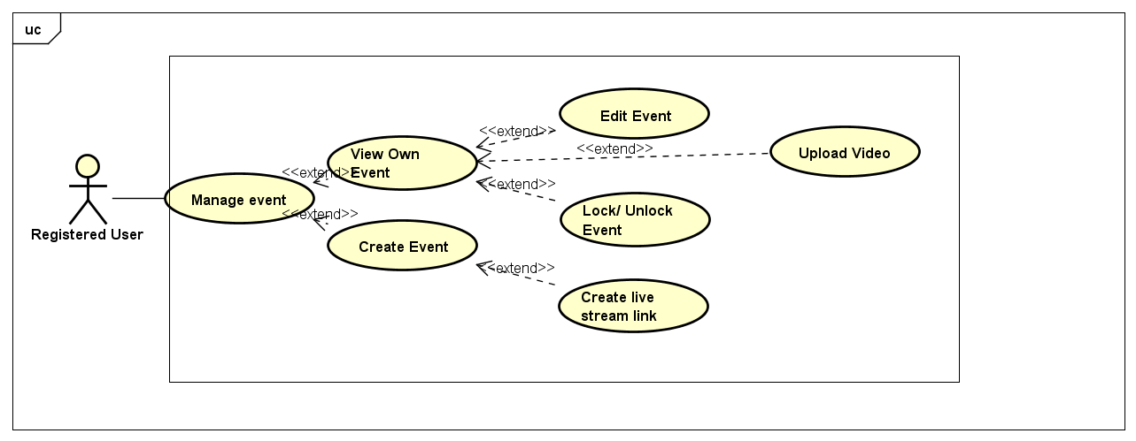

##### UC-020: Manage Event

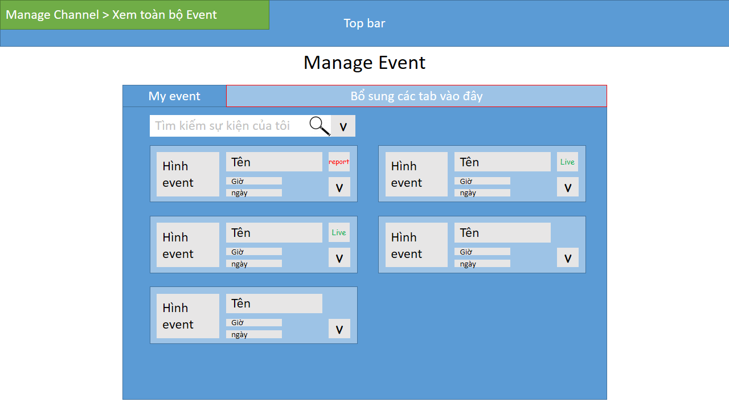

Figure 15 View Event

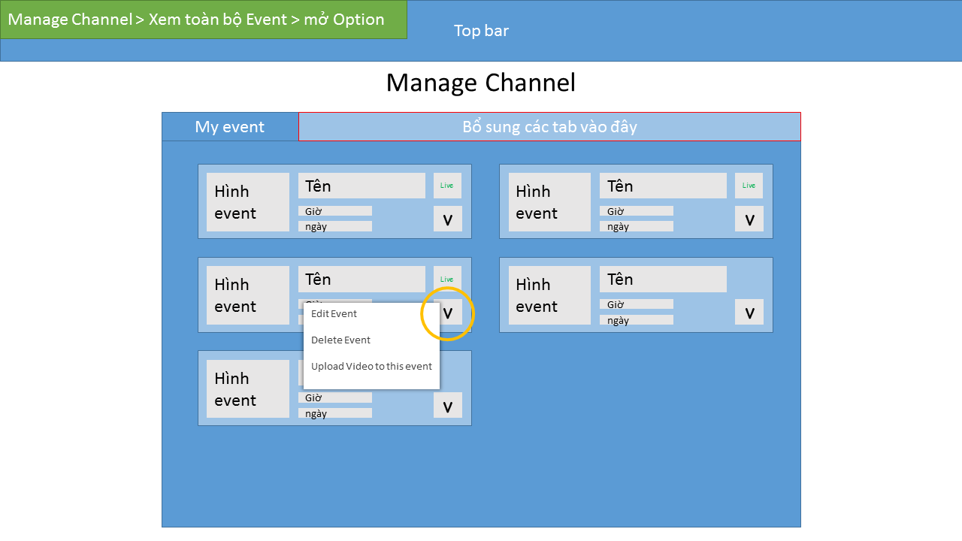

Figure 16 Manage Event

|  |  |  |  |  |
| --- | --- | --- | --- | --- |
| Use Case Name | Manage event | | | |
| Use Case ID | UC-020 | | | |
| Created By | DuongNN | **Last Updated By** | | DuongNN |
| Date Created | 22/09/2015 | **Date Last Updated** | | 29/09/2015 |
| Actor | Registered User | | | |
| Goal/Description | Allow users to manage their own created event | | | |
| Pre-Condition | User logins website as Registered User. User is at any Website screen. | | | |
| Trigger | User wants to Manage their event | | | |
| Post Condition | Manage event screen is shown | | | |
| Basic Path | Actor’s Action | | System’s Response | |
|  | 1. Click on “Avatar” button | | Redirect to Manage Event screen | |
| Alternative Paths |  | |  | |
| Exception Paths |  | |  | |
| Notes | List of User’s events is default for Manage Event screen | | | |

##### UC-021: View Own Event

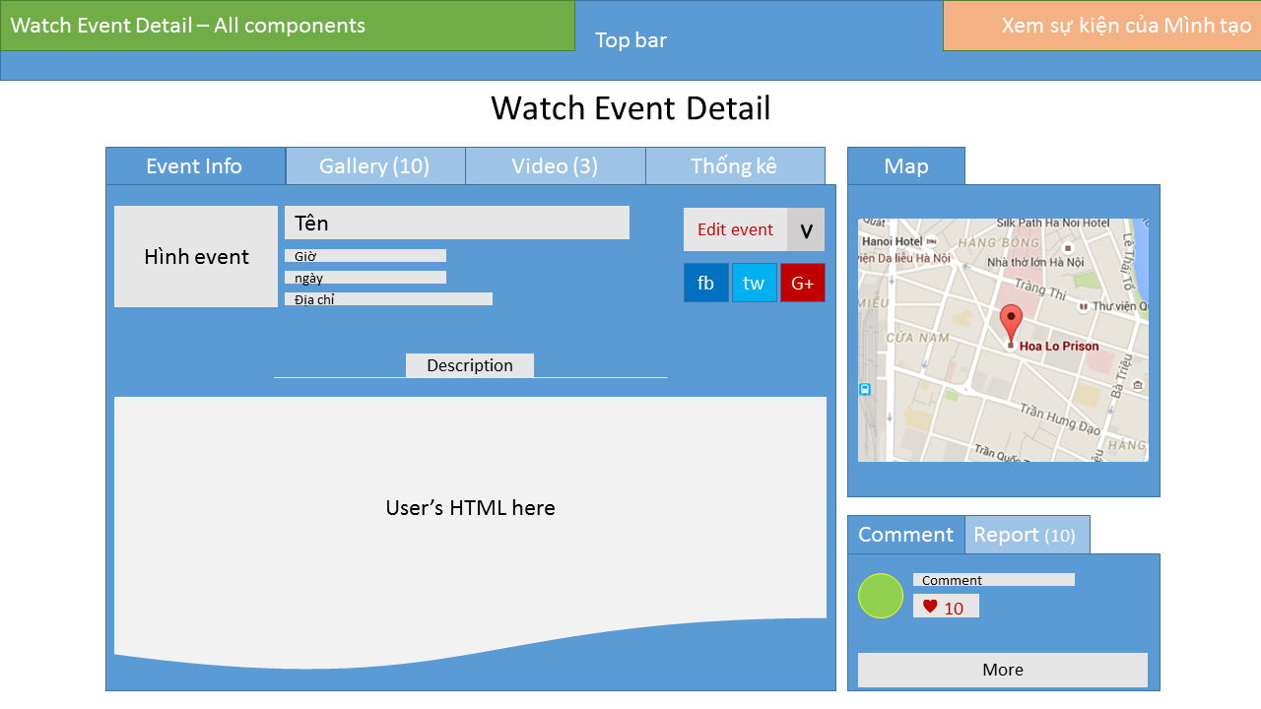

Figure 17 View Own Event

|  |  |  |  |  |
| --- | --- | --- | --- | --- |
| Use Case Name | View Own Event | | | |
| Use Case ID | UC-021 | | | |
| Created By | DuongNN | **Last Updated By** | | DuongNN |
| Date Created | 22/09/2015 | **Date Last Updated** | | 29/09/2015 |
| Actor | Registered User | | | |
| Goal/Description | Allow users toview their own created event | | | |
| Pre-Condition | User logins website as Registered User. User is at Manage Events Screen. | | | |
| Trigger | User wants to view all their own events | | | |
| Post Condition | Manage event screen is shown | | | |
| Basic Path | Actor’s Action | | System’s Response | |
|  | 1. Click on “Avatar” butotn | | Redirect to Manage event screen | |
| Alternative Paths |  | |  | |
| Exception Paths |  | |  | |
| Notes | List of User’s events is default for Manage Event screen | | | |

##### UC-022: Edit Event

|  |  |  |  |  |  |
| --- | --- | --- | --- | --- | --- |
| Use Case Name | Edit Event | | | | |
| Use Case ID | UC-022 | | | | |
| Created By | DuongNN | | **Last Updated By** | | DuongNN |
| Date Created | 22/09/2015 | | **Date Last Updated** | | 29/09/2015 |
| Actor | Registered User | | | | |
| Goal/Description | Allow users to edit events’ information. | | | | |
| Pre-Condition | User logins website as Registered User. User is at Watch Event Screen | | | | |
| Trigger | User wants to Edit their event’s information | | | | |
| Post Condition | New information is saved successfully | | | | |
| Basic Path | Actor’s Action | | | System’s Response | |
|  | 1. Click on “Edit” button   *There is an exception path: A1* | | | Redirect to Edit event screen | |
| 1. User fill in new information   *There are exception paths: E1, E2, E3, E4* | | |  | |
| 1. Click on “Save” button   *There is an exception path: E5* | | | Redirect to Watch Event screen, screen will show a notice: “New information saved.” | |
| Alternative Paths | **A1.** | Actor’s Action | | System’s Response | |
| 1. Click on “Avatar” button | | Redirect to Manage event screen | |
| 1. Move on any Event in this list | | “More” button will be shown in whenever mouse is hovering an event | |
| 1. Click on “More” button | | A dropdown group of button is shown including “Edit information” button. | |
| 1. Click on “Edit information” button | | Redirect to Edit event screen | |
| 1. User fill in new information   *There are exception paths: E1, E2, E3, E4* | |  | |
| 1. Click on “Save” button   *There is an exception path: E5* | | Redirect to Watch Event screen, screen will show a notice: “New information saved.” | |
| Exception Paths |  | Actor’s Action | | System’s Response | |
| **E1.** | Event’s Name is empty | | Display a notice: “This field can’t be empty.” | |
| **E2.** | Event’s Time is empty | | Display a notice: “This field can’t be empty.” | |
| **E3.** | Event’s Location is empty | | Display a notice: “This field can’t be empty.” | |
| **E4.** | Event’s Description is empty | | Display a notice: “This field can’t be empty.” | |
| **E5.** | Click on “Cancel” button | | All changes is not saved. Redirect to Watch Event screen (or Manage Event – depend on where User stands before) | |
| Notes | List of User’s events is default for Manage Event screen | | | | |

##### UC-023: Lock Event

|  |  |  |  |  |  |
| --- | --- | --- | --- | --- | --- |
| Use Case Name | Lock event | | | | |
| Use Case ID | UC-023 | | | | |
| Created By | DuongNN | | **Last Updated By** | | DuongNN |
| Date Created | 22/09/2015 | | **Date Last Updated** | | 29/09/2015 |
| Actor | Registered User | | | | |
| Goal/Description | Allow user Lock an event. | | | | |
| Pre-Condition | User logins website as Registered User. User is at Watch Event Screen.  Event’s status is Public or Unlisted. | | | | |
| Trigger | User wants to Lock an event. | | | | |
| Post Condition | Event is Lock successfully. | | | | |
| Basic Path | Actor’s Action | | | System’s Response | |
|  | 1. Click on “More” button   *There is an alternative path: A1* | | | A dropdown group of button is shown including “Lock event” button | |
| 1. Click on “Lock event” button | | | A popup is shown to confirm the Lock action: “This event will be Locked. Are you sure?” including 2 button “Yes/No” | |
| 1. Click on “Yes” button   *There is an exception path: E1* | | | Redirect to Watch Event screen, screen will show a notice: “Event is set to Private.” | |
| Alternative Paths |  | User’s Action | | System’s Response | |
| **A1.** | 1. Click on “Avatar” button | | Redirect to Manage event screen | |
| 1. Move on any Event in this list | | “More” button will be shown in whenever mouse is hovering an event | |
| 1. Click on “More” button | | A dropdown group of button is shown including “Lock event” button. | |
| 1. Click on “Lock event” button | | Redirect to Edit event screen | |
| 1. Click on “Yes” button   *There is an exception path: E1* | | Redirect to Watch Event screen, screen will show a notice: “Event is set to Private.” | |
| Exception Paths |  | Actor’s Response | | System’s Response | |
|  | **E1.** | Click on “No” button | | Redirect to Watch Event screen, screen will show a notice: “Event status not changed.” | |
| Notes | List of User’s events is default for Manage Event screen | | | | |

##### UC-024: Unlock Event

|  |  |  |  |  |  |
| --- | --- | --- | --- | --- | --- |
| Use Case Name | Unlock event | | | | |
| Use Case ID | UC-024 | | | | |
| Created By | DuongNN | | **Last Updated By** | | DuongNN |
| Date Created | 22/09/2015 | | **Date Last Updated** | | 29/09/2015 |
| Actor | Registered User | | | | |
| Goal/Description | Allow user Unlock an event. | | | | |
| Pre-Condition | User logins website as Registered User. User is at Watch Event Screen.  Event’s status is Private. | | | | |
| Trigger | User wants to Unlock an event. | | | | |
| Post Condition | Event is Unlock successfully. | | | | |
| Basic Path | Actor’s Action | | | System’s Response | |
|  | 1. Click on “More” button   *There is an alternative path: A1* | | | A dropdown group of button is shown including “Unlock event” button | |
| 1. Click on “Lock event” button | | | A popup is shown to confirm the Unlock action: “This event will be Unlocked. Are you sure?” including 2 button “Public/Private/Cancel” | |
| 1. Click on “Public/Private” button   *There is an exception path: E1* | | | Redirect to Watch Event screen, screen will show a notice: “Event is set to Public/Private.” | |
| Alternative Paths |  | Actor’s Action | | System’s Response | |
| **A1.** | 1. Click on “Avatar” button | | Redirect to Manage event screen | |
| 1. Move on any Event in this list | | “More” button will be shown in whenever mouse is hovering an event | |
| 1. Click on “More” button | | A dropdown group of button is shown including “Unlock event” button. | |
| 1. Click on “Unlock event” button | | Redirect to Edit event screen | |
| 1. Click on “Public/Private” button   *There is an exception path: E1* | | Redirect to Watch Event screen, screen will show a notice: “Event is set to Private.” | |
| Exception Paths |  | Actor’s Action | | System’s Response | |
|  | **E1.** | Click on “Cancel” button | | Redirect to Watch Event screen, screen will show a notice: “Event status not changed.” | |
| Notes | List of User’s events is default for Manage Event screen | | | | |

##### UC-025: Upload Video

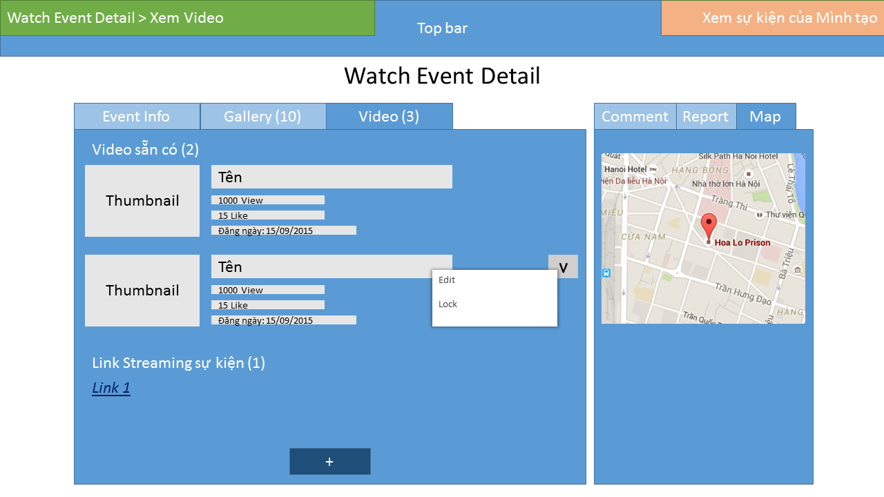

Figure 18 Add New Video

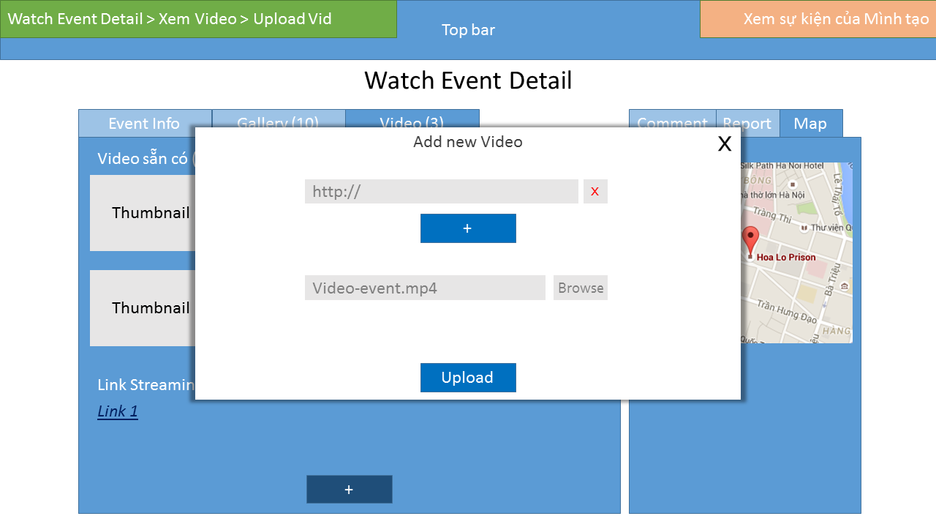

Figure 19 Upload Video

|  |  |  |  |  |  |
| --- | --- | --- | --- | --- | --- |
| Use Case Name | Upload Video | | | | |
| Use Case ID | UC-025 | | | | |
| Created By | DuongNN | | **Last Updated By** | | DuongNN |
| Date Created | 22/09/2015 | | **Date Last Updated** | | 29/09/2015 |
| Actor | Registered User | | | | |
| Goal/Description | Allow user upload videos to an event. | | | | |
| Pre-Condition | User logins website as Registered User. User is at Watch Events Screen | | | | |
| Trigger | User wants to upload videos to an event. | | | | |
| Post Condition | Video is added to an event successfully. | | | | |
| Basic Path | Actor’s Action | | | System’s Response | |
|  | 1. Click on “More” button   *There are alternative paths: A1, A2* | | | A dropdown group of button is shown included “Upload Video” button | |
| 1. Click on “Upload Video” button | | | Display Upload Video Popup. | |
| 1. Click on “Browser” button | | | An explore window is shown | |
| 1. Browse the video User wants to upload, click OK. | | | Name of the video is filled into the textbox. | |
| 1. Click “Upload” button   *There is an exception path: E1, E2, E3, E4* | | | After Video uploaded to server successful, screen will notice: “New Video uploaded successfully”. Redirect to Watch Event screen. | |
| Alternative Paths |  | Actor’s Action | | System’s Response | |
| **A1.** | 1. Click on “Video” Tab | | A list of Video is shown, included “Upload Video” button | |
| 1. Click on “Upload Video” button | | Display Upload Video Popup. | |
| 1. Click on “Browser” button | | An explore window is shown | |
| 1. Browse the video User wants to upload, click OK. | | Name of the video is filled into the textbox. | |
| 1. Click “Upload” button   *There is an exception path: E1, E2, E3, E4* | | After Video uploaded to server successful, screen will notice: “New Video uploaded successfully”. Redirect to Watch Event screen. | |
| **A2.** | 1. (Pre-condition)   User is at Manage Event Screen | | (List of Events is shown) | |
| 1. Move on any Event in this list | | “More” button will be shown in whenever mouse is hovering an event | |
| 1. Click on “More” button | | A dropdown group of button is shown included “Upload Video” button | |
| 1. Click on “Upload Video” button | | Display Upload Video Popup. | |
| 1. Click on “Browser” button | | An explore window is shown | |
| 1. Browse the video User wants to upload, click OK. | | Name of the video is filled into the textbox. | |
| 1. Click “Upload” button   *There is an exception path: E1, E2, E3, E4* | | After Video uploaded to server successful, screen will notice: “New Video uploaded successfully”. Redirect to Watch Event screen. | |
| Exception Paths |  | Actor’s Action | | System’s Response | |
|  | **E1.** | If there is any internet connection problem, uploading progress is fail | | Video is not saved successful.  Screen will notice: “Uploading progress is fail”. | |
|  | **E2.** | If there is no Video is selected when “Upload” button is clicked | | Screen will notice: “Please choose a video to upload.” | |
|  | **E3.** | User choose an invalid file types (such as Image, Sound file) | | Screen will notice: “Please choose a video to upload.” | |
|  | **E4.** | Click “Cancel” button | | Uploading progress is stopped. | |
| Notes | List of User’s events is default for Manage Event screen | | | | |

##### UC-026: Create Event

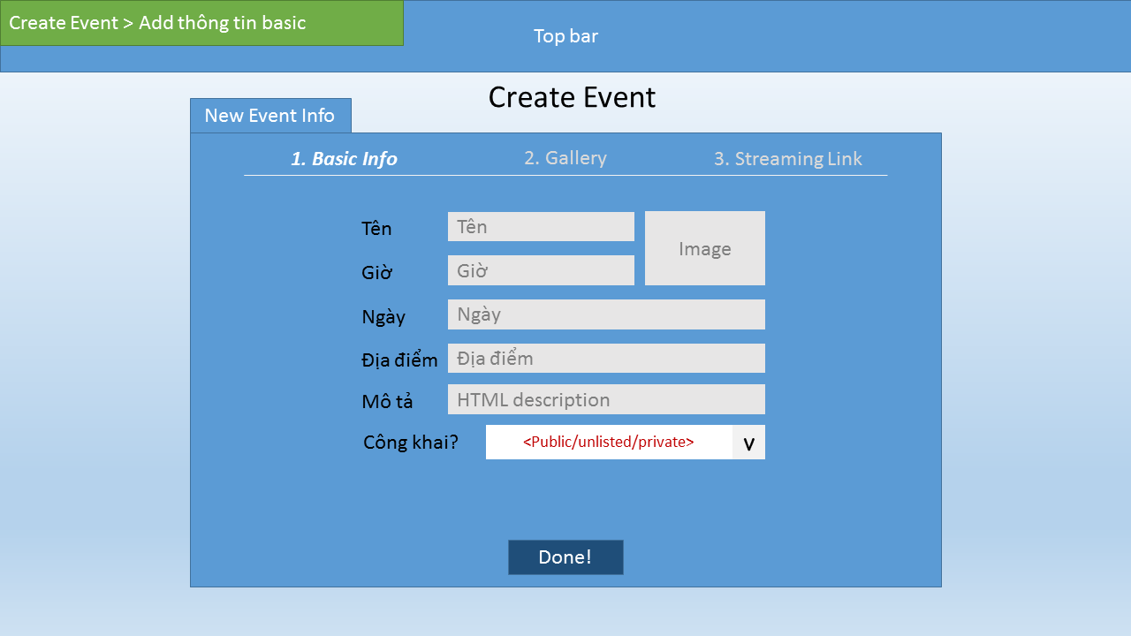

Figure 20 Create Event Bassic Info

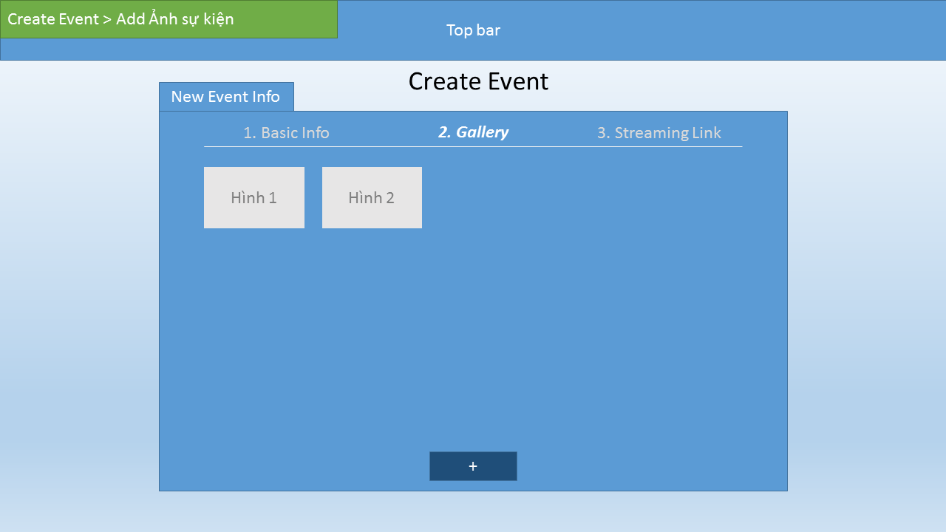

Figure 21 Add Image

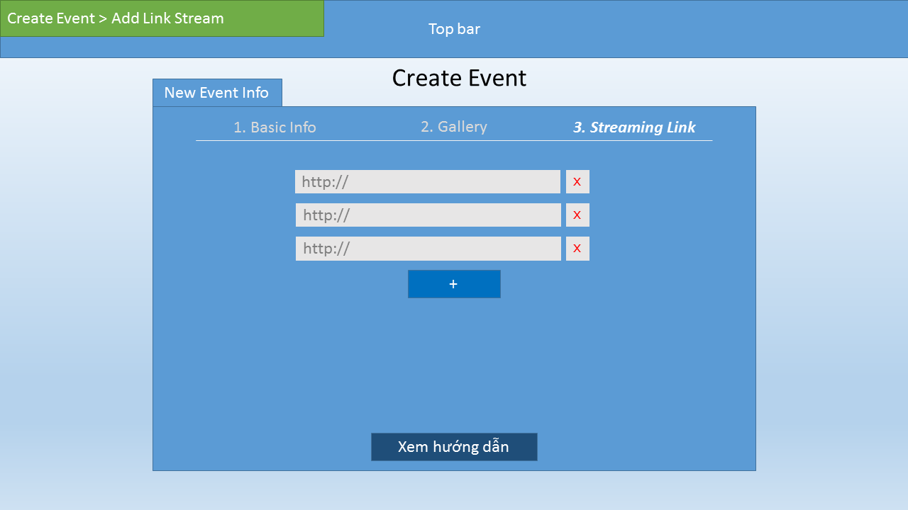

Figure 22 Add Video Link

|  |  |  |  |  |  |
| --- | --- | --- | --- | --- | --- |
| Use Case Name | Create Event | | | | |
| Use Case ID | Use Case điền sau | | | | |
| Created By | DuongNN | | **Last Updated By** | | DuongNN |
| Date Created | 22/09/2015 | | **Date Last Updated** | | 29/09/2015 |
| Actor | Registered User | | | | |
| Goal/Description | Allow user create an event. | | | | |
| Pre-Condition | User logins website as Registered User. User is at any Website Screen | | | | |
| Trigger | User wants to create an event. | | | | |
| Post Condition | A new event is added successfully. | | | | |
| Basic Path | Actor’s Action | | | System’s Response | |
|  | 1. Click on “Create Event” button | | | Redirect to Create Event screen. | |
| 1. Fill all required information, add image, add link Video | | |  | |
| 1. Click on “Create” button   *There is an exception path: E1, E2, E3, E4, E5* | | | Screen will notice: “New Event is created successfully”. Redirect to View Detail Event screen. | |
| Alternative Paths |  | | |  | |
| Exception Paths |  | Actor’s Action | | System’s Response | |
|  | **E1.** | Event’s Name is empty | | Display a notice: “This field can’t be empty.” | |
|  | **E2.** | Event’s Time is empty | | Display a notice: “This field can’t be empty.” | |
|  | **E3.** | Event’s Location is empty | | Display a notice: “This field can’t be empty.” | |
|  | **E4.** | Event’s Description is empty | | Display a notice: “This field can’t be empty.” | |
|  | **E5.** | Click on “Cancel” button | | All changes is not saved. Redirect to Watch Event screen (or Manage Event – depend on where User stands before) | |
| Notes |  | | | | |

##### UC-027: Create Live Streaming Link

|  |  |  |  |  |  |
| --- | --- | --- | --- | --- | --- |
| Use Case Name | Create Live Streaming Link | | | | |
| Use Case ID | Use Case điền sau | | | | |
| Created By | DuongNN | | **Last Updated By** | | DuongNN |
| Date Created | 22/09/2015 | | **Date Last Updated** | | 29/09/2015 |
| User | Registered User | | | | |
| Goal/Description | Allow user create an event included Live Streaing Service | | | | |
| Pre-Condition | User logins website as Registered User. User is at Create Event screen. | | | | |
| Trigger | User wants to create an event included Live Streaming Video | | | | |
| Post Condition | A new Live Streaming Link is created successfully. | | | | |
| Basic Path | Actor’s Action | | | System’s Response | |
|  | 1. Click on “Video” Tab   *There is an alternative paths: A1* | | | Videos and Upload button are displayed | |
| 1. In the new tab, Follow Steps and the Link is copied. | | |  | |
| 1. Return to Create Event Screen, paste the link into the textbox | | |  | |
| 1. Click on “Create” button   *There is an exception path: E1, E2, E3, E4, E5* | | | Screen will notice: “New Event is created successfully”. Redirect to Watch Event screen. | |
| Alternative Paths |  | Actor’s Action | | System’s Response | |
| **A1.** | 1. (Pre-condition)   User is at Watch Event Screen | |  | |
| 1. Click on “Video” Tab | | Videos and Upload button are displayed | |
| 1. In the new tab, Follow Steps and the Link is copied. | |  | |
| 1. Return to Create Event Screen, paste the link into the textbox | |  | |
| 1. Click on “Create” button   *There is an exception path: E1, E2, E3, E4, E5* | | Screen will notice: “New Event is created successfully”. Redirect to Watch Event screen. | |
| Exception Paths |  | Actor’s Action | | System’s Response | |
|  | **E1.** | Click “Create” button while the textbox is empty. | | Display a notice: “This field can’t be empty.” | |
| Notes |  | | | | |

##### UC-028: Lock/Unlock Event

|  |  |  |  |  |
| --- | --- | --- | --- | --- |
| Use Case Name | Lock/Unlock Event | | | |
| Use Case ID | Use Case điền sau | | | |
| Created By | DuongNN | **Last Updated By** | | DuongNN |
| Date Created | 22/09/2015 | **Date Last Updated** | | 29/09/2015 |
| Actor | Moderators | | | |
| Goal/Description | Allow Moderators lock/unlock an event that it’s in Appeal status | | | |
| Pre-Condition | User logins website as Moderators | | | |
| Trigger | Moderators decide to Lock any violated Event | | | |
| Post Condition | An event is Lock/Unlock successfully. | | | |
| Basic Path | Actor’s Action | | System’s Response | |
|  | 1. Click on “Report statistic” button | | A list of violated event is shown. | |
| 1. On each event of list, click “More” button | | A dropdown group of button is shown included “Lock event” and “Unlock event” button | |
| 1. Click on “Lock/Unlock” button | | Screen will notice: “This event is Locked/Unlocked successfully”.  A notification will be sent to that event’s Owner.  Moderator still stay on this screen. | |
| Alternative Paths |  | |  | |
| Exception Paths |  | |  | |
| Notes |  | | | |

### Moderator Functions

#### Manage Event

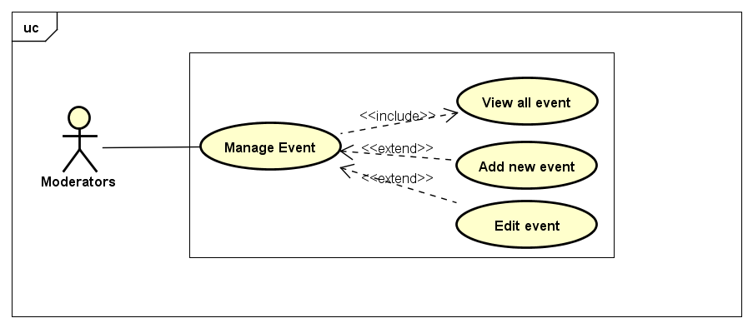

##### UC-029: View All Event

|  |  |  |  |  |
| --- | --- | --- | --- | --- |
| Use Case Name | View All Event | | | |
| Use Case ID | UC-029 | | | |
| Created By | CuongNV | **Last Updated By** | | CuongNV |
| Date Created | 22/09/2015 | **Date Last Updated** | | 28/09/2015 |
| Actor | Moderators | | | |
| Goal/Description | This use case allow Moderator views all events in system. | | | |
| Pre-Condition | Moderator logs in to Event Zone. | | | |
| Trigger | Moderator wants to view all events in Event Zone’s system. | | | |
| Basic Path | Actor’s Action | | System’s response | |
|  | 1. Actor click on button setting in the right top website | | Shows user’s Menu | |
| 1. Actor click on Manage Event | | Redirects to Manage Event Page, and shows all events in the system | |
| Alternative Paths | N/A | | | |
| Exception Paths | N/A | | | |
| Post Condition | System redirects to Manage Event Page and shows all event in the system | | | |
| Notes |  | | | |

##### UC-030: Edit User’s Event

|  |  |  |  |  |  |
| --- | --- | --- | --- | --- | --- |
| Use Case Name | Edit User’s Event | | | | |
| Use Case ID | UC-030 | | | | |
| Created By | CuongNV | | **Last Updated By** | | CuongNV |
| Date Created | 22/09/2015 | | **Date Last Updated** | | 28/09/2015 |
| Actor | Moderators | | | | |
| Goal/Description | This use case allow Moderator edits content of user’s event. | | | | |
| Pre-Condition | Actor logins website as Moderators. System current shows an event or list of events in current screen. | | | | |
| Trigger | Moderator want to edit user’s event in Event Zone’s system. | | | | |
| Basic Path | Actor’s Action | | | System’s response | |
| 1. Actor click on button “Edit” in the right top of event’s thumbnail in the current screen.   *There is an alternative path: A1* | | | Redirects to edit’s event page. | |
| 1. Actor updates fields of event and click on button “Save”.   *There are exception paths: E1, E2* | | | System displays edit confirmation pop-up. | |
| 1. Actor select button “Yes”.   *There is exception path: E4* | | | System update fields of event and save to database. System also determines that this event is last edited by this actor. System informs to user that update successful and redirect to view detail event page of edited event. | |
| Alternative Paths | **A1.** | Actor’s Action | | System’s response | |
| 1. Click on button edit “Edit” in the right top of event. | | Redirects to edit’s event page. | |
| 2. Go to Step 2 in Basic Path. | |  | |
| Exception Paths |  | Actor’s Action | | System’s response | |
| **E1.** | 2. Actor click on button “Cancel” | | System displays exit edit confirmation pop-up. | |
| 3. Actor select button “Yes” | | System redirect to previous page of actor. | |
| **E2** | 2. Actor don’t fill the event title field and click on button “Save” | | System reloads page and shows notice “Event Location cannot empty”. | |
| **E3** | 2.Actor don’t fill the event location’s field and click on button “Save” | | System reloads page and shows the notice “Event Location cannot empty”. | |
| **E4.** | Actor’s Action | | System’s response | |
| 1. Actor select button “No” | | Redirects to edit’s event page. | |
| 2. Go to Step 2 in Basic Path. | | System redirect to previous page of actor. | |
| Post Condition | If basic or alternative path is successful, system redirect to view detail event page of edited event.  If exception are thrown, the result must match with output of each described exception. | | | | |
| Notes |  | | | | |

##### UC-031: Add New Event

|  |  |  |  |  |  |
| --- | --- | --- | --- | --- | --- |
| Use Case Name | Add New Event | | | | |
| Use Case ID | UC-031 | | | | |
| Created By | CuongNV | | **Last Updated By** | | CuongNV |
| Date Created | 22/09/2015 | | **Date Last Updated** | | 28/09/2015 |
| Actor | Moderator | | | | |
| Goal/Description | This use case allow Moderator adds an verify event. | | | | |
| Pre-Condition | Actor logged in to website as Moderator. Actor current access to the Manage event page. | | | | |
| Trigger | Actor determines add verify event. | | | | |
|  | Actor’s Action | | | System’s Response | |
| Basic Path | 1. Click to button Add new event | | | Redirect to mod’s add new event page. | |
| 1. Fill all mandatory fields and click on button “Create”   *There are exception paths: E1, E2, E3, E4, E5* | | | System displays add new event confirmation pop-up. | |
| 1. Actor select button “Yes”.   *There is exception path: E6* | | | System save new event to database. System informs to Actor that add new event successful and redirect to view detail event page new event. | |
| Alternative Paths | **N/A** | | | | |
| Exception Paths | **E1.** | Actor’s Action | | System’s response | |
| 2. Actor click on button “Cancel” | | System displays exit add new event confirmation pop-up. | |
| 3. Actor select button “Yes” | | System redirect to previous page of actor. | |
| **E2.** | 2. Actor don’t fill the event title field and click on button “Create” | | System reloads page and shows notice “Event title cannot empty and must be contain only alphabet or number character.” | |
| **E3.** | 2. Actor don’t select the Event’s start date and click on button “Create” | | System reloads page and shows notice “Please select time to start event” | |
| **E4.** | 2. Actor don’t fill the event location field and click on button “Create” | | System reloads page and shows notice “Event’s location cannot empty” | |
| **E5.** | 2. Selects option create live stream but his/her YouTube account is not verified account | | System reloads page and shows notice “Your YouTube account must be verified account to use create live stream feature” | |
| **E6.** | Actor’s Action | | System’s response | |
| 1. Actor select button “No” | | Pop-up is closed. | |
| 2. Go to Step 2 in Basic Path. | |  | |
| Post Condition | If basic path is successful, new event is created in database. System redirect to view detail event page of new event.  If exception are thrown, the result must match with output of each described exception. | | | | |
| Notes |  | | | | |

#### Manage Violation Reports

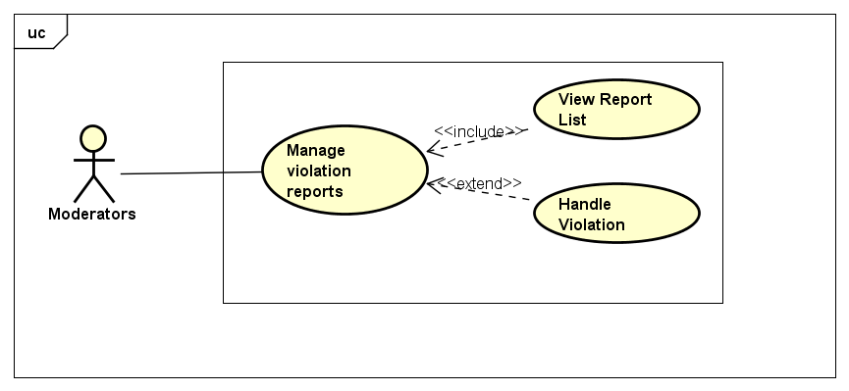

##### UC-032: View Violation Report List

|  |  |  |  |  |
| --- | --- | --- | --- | --- |
| Use Case Name | View Violation Report List | | | |
| Use Case ID | UC-032 | | | |
| Created By | CuongNV | **Last Updated By** | | CuongNV |
| Date Created | 22/09/2015 | **Date Last Updated** | | 23/09/2015 |
| Actor | Moderator | | | |
| Goal/Description | This use case allow Moderator views all violation reports in system. | | | |
| Pre-Condition | Actor logged in to website as Moderator. | | | |
| Trigger | Actor wants to view all reports in the system. | | | |
|  | Actor’s Action | | System’s Response | |
| Basic Path | 1. Actor click on button setting in the right top website | | Shows user’s Menu | |
| 1. Actor click on Manage Report | | Redirects to Manage Reports Page, and shows all events in the system | |
| Alternative Paths | N/A | | | |
| Exception Paths | N/A | | | |
| Post Condition | System redirects to Manage Report Page and shows all reports in the system. | | | |
| Notes |  | | | |

##### UC-033: Handle Violation Report

|  |  |  |  |  |  |
| --- | --- | --- | --- | --- | --- |
| Use Case Name | Handle Violation Report | | | | |
| Use Case ID |  | | | | |
| Created By | CuongNV | | **Last Updated By** | | CuongNV |
| Date Created | 22/09/2015 | | **Date Last Updated** | | 28/09/2015 |
| Actor | Moderators | | | | |
| Goal/Description | This use case allow Moderator handles user’s report. | | | | |
| Pre-Condition | Actor logins website as Moderators. System current shows Manage Reports Page. | | | | |
| Trigger | Moderator want to handle violation report in Event Zone’s system. | | | | |
| Basic Path | Actor’s Action | | | System’s response | |
| 1. Actor selects a pending report from list report. | | | Redirects to view report detail. | |
| 1. Actor click on button “Approve” in the report   *There is an alternative path: A1*  *There is an exception path: E1* | | | System change report status to “Approved” and hidden both button “Approve” and “Reject”. System sends message to report’s sender that his action is approved, and inform to report’s receiver that his event violate system’s privacy. Violation event which is reported in this report is locked. The report’s detail page is reloaded. | |
| Alternative Paths | **A1.** | Actor’s Action | | System’s response | |
| 2. Click on button “Reject” in the report | | System change report status to “Reject” and hidden both button “Approve” and “Reject”. System sends message to report’s sender that his action is rejected. The report’s detail page is reloaded. | |
| Exception Paths | **E1.** | Actor’s Action | | System’s response | |
| 2. Actor click on button “Back to violation report list” | | Redirect to Manage violation reports page. | |
| Post Condition | If basic path is successful, system changes report status and reloads the report’s detail page.  If exception are thrown, the result must match with output of each described exception. | | | | |
| Notes | There are 3 status of report:   * “Pending” report: report is not handled. * “Approved” report: report is determined that the information given in the report is exactly and it must be handle. * “Reject” report: report determined that the information given in the report is not true and it will be ignore. | | | | |

#### Manage Appeal

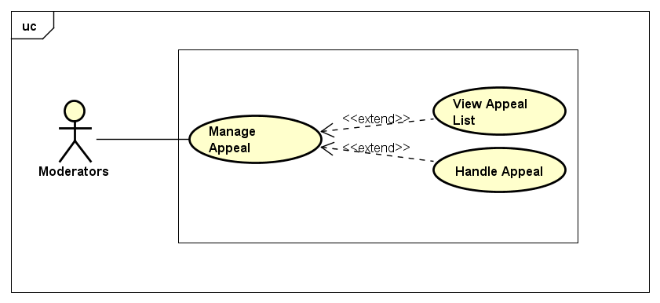

##### UC-034: View Appeal List

|  |  |  |  |  |
| --- | --- | --- | --- | --- |
| Use Case Name | View Appeal List | | | |
| Use Case ID | UC-034 | | | |
| Created By | CuongNV | **Last Updated By** | | CuongNV |
| Date Created | 23/09/2015 | **Date Last Updated** | | 28/09/2015 |
| Actor | Moderator | | | |
| Goal/Description | This use case allow Moderator views all appeals of reports in system. | | | |
| Pre-Condition | Actor logged in to website as Moderator. | | | |
| Trigger | Actor wants to view all reports in the system. | | | |
| Basic Path | Actor’s Action | | System’s Response | |
| 1. Actor click on button setting in the right top website | | Shows user’s Menu | |
| 1. Actor click on Manage Appeal | | Redirects to Manage Appeal Page, and shows all appeal in the system | |
| Alternative Paths | N/A | | | |
| Exception Paths | N/A | | | |
| Post Condition | System redirects to Manage Appeal Page and shows all appeal in the system | | | |
| Notes |  | | | |

##### UC-035: Handle Appeal

|  |  |  |  |  |  |
| --- | --- | --- | --- | --- | --- |
| Use Case Name | HandleAppeal | | | | |
| Use Case ID | UC-035 | | | | |
| Created By | CuongNV | | **Last Updated By** | | CuongNV |
| Date Created | 23/09/2015 | | **Date Last Updated** | | 28/09/2015 |
| Actor | Moderator | | | | |
| Goal/Description | This use case allow Moderator handle appeal of reports in system. | | | | |
| Pre-Condition | Actor logins website as Moderators. System current shows Manage Appeal Page. | | | | |
| Trigger | Moderator want to handle appeal in Event Zone’s system. | | | | |
| Basic Path | Actor’s Action | | | System’s Response | |
| 1. Actor selects pending appeal from list appeal. | | | Redirects to view appeal detail. | |
| 1. Actor click on button “Approve” in the report   *There is an alternative path: A1*  *There is an exception path: E1* | | | System change report status to “Approved” and hidden both button “Approve” and “Reject”. System sends message to appeal’s sender that his action is approved. Reported event which is related to this appeal is set to unlocked. The appeal’s detail page is reloaded. | |
| Alternative Paths | **A1.** | Actor’s Action | | System’s response | |
| 2. Actor click on button “Reject” in the appeal | | System change appeal status to “Reject” and hidden both button “Approve” and “Reject”. System sends message to appeal’s sender that his action is rejected. The appeal’s detail page is reloaded. | |
| Exception Paths | **E1.** | Actor’s Action | | System’s response | |
| 2. Actor click on button “Back to appeal list” | | Redirect to Manage appeal page. | |
| Post Condition | If basic path is successful, system updates appeal’s status and reported event’s status, reload appeal’s detail page.  If exception are thrown, the result must match with output of each described exception. | | | | |
| Notes |  | | | | |

#### UC-036: View Statistic

|  |  |  |  |  |
| --- | --- | --- | --- | --- |
| Use Case Name | View Statistic | | | |
| Use Case ID | UC-036 | | | |
| Created By | CuongNV | **Last Updated By** | | CuongNV |
| Date Created | 22/09/2015 | **Date Last Updated** | | 28/09/2015 |
| Actor | Moderator | | | |
| Goal/Description | This use case allow Moderators view statistics about their actions in website, overview about number of users, video, reports… | | | |
| Pre-Condition | Actor logged in to website as Moderator. | | | |
| Trigger | Actor want to view his/her actions in website, view overall website. | | | |
| Basic Path | Actor’s Action | | System’s Response | |
| 1. Actor click on button setting in the right top website | | Shows user’s Menu | |
| 1. Actor click on View Statistic | | Redirects to Mod’s Statistic Page, and shows all overall statistics of the website via graph and numbers. | |
| Alternative Paths | N/A | | | |
| Exception Paths | N/A | | | |
| Post Condition | The system redirects to mod’s statistic page, shows graphs and statistics about website and record of Moderator’s actions. | | | |
| Notes |  | | | |

### Admin Functions

#### UC-037: Sign In

|  |  |  |  |  |  |
| --- | --- | --- | --- | --- | --- |
| Use Case Name | Sign in | | | | |
| Use Case ID | UC-037 | | | | |
| Created By | ChuongNT | **Last Updated By** | | | ChuongNT |
| Date Created | 21/09/2015 | **Date Last Updated** | | | 29/09/2015 |
| Actor | Admin, Root Admin | | | | |
| Goal/Description | This use case allow Actor sign in to Admin’s Management Screen | | | | |
| Pre-Condition | Actor is not sign in. System current shows Sign in Page. | | | | |
| Trigger | Actor wants to login | | | | |
| Basic Path | Actor’s action | | | System’s response | |
|  | 1. Enter username and password.   *There are six exceptions: E1, E2, E3, E4, E5, E6* | | |  | |
| 1. Click on “Sign in” button | | | Redirect to Index Screen | |
| Exception Paths | E1. If actor enter the wrong username | | The screen will show the massage “Username is incorrect!” | | |
| E2. If actor enter the wrong username | | The screen will show the massage “Password is incorrect!” | | |
| E3. If actor enter the wrong both username and password | | The screen will show the massage “Password is incorrect!” | | |
| E4. If actor did not enter the username | | The screen will show the massage “Username must be filled!” | | |
| E5. If actor did not enter the password | | The screen will show the massage “Username must be filled!” | | |
| E6. If actor did not enter both username and password | | The screen will show the massage “Username and password must be filled!” | | |
| Post Condition | Actor logged in. System current shows Index Page. | | | | |

#### UC-038: Sign Out

|  |  |  |  |  |
| --- | --- | --- | --- | --- |
| Use Case Name | Sign out | | | |
| Use Case ID | UC-038 | | | |
| Created By | ChuongNT | **Last Updated By** | | ChuongNT |
| Date Created | 21/09/2015 | **Date Last Updated** | | 29/09/2015 |
| Actor | Admin, Root Admin | | | |
| Goal/Description | This use case allow Actor log out system | | | |
| Pre-Condition | Actor is logged in | | | |
| Trigger | Actor wants to logout | | | |
| Basic Path | Actor’s action | | System’s response | |
|  | 1. Click on “Sign out” | | Redirect to the Login Screen | |
| Post Condition | Actor logout of the system. System current shows Sign in Page. | | | |

#### Manage Users

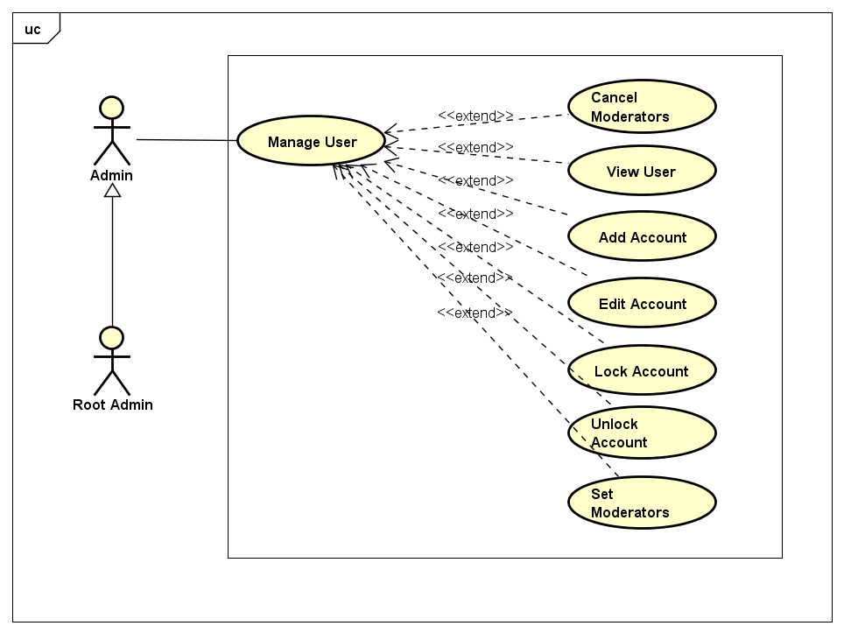

##### UC-039: View Users

|  |  |  |  |  |
| --- | --- | --- | --- | --- |
| Use Case Name | View Users | | | |
| Use Case ID | UC-039 | | | |
| Created By | ChuongNT | **Last Updated By** | | ChuongNT |
| Date Created | 22/09/2015 | **Date Last Updated** | | 29/09/2015 |
| Actor | Admin, Root Admin | | | |
| Goal/Description | This use case allow actor view all users | | | |
| Pre-Condition | Actor is logged in. System current shows Manage Users Page. | | | |
| Trigger | Actor wants to view all users in Event Zone’s system. | | | |
|  | Actor’s Action | | System’s Response | |
| Basic Path | 1. Click “View Users” button | | Redirect to the View Users Screen | |
| Post Condition | System show all user information in system about: username, password, first name, last name, email, date of birth, ID card, user role, phone, place, account status, gender, avatar link. System current shows View Users Page. | | | |

##### UC-040: Add Account

|  |  |  |  |  |  |
| --- | --- | --- | --- | --- | --- |
| Use Case Name | Add Account | | | | |
| Use Case ID | UC-040 | | | | |
| Created By | ChuongNT | **Last Updated By** | | | ChuongNT |
| Date Created | 21/09/2015 | **Date Last Updated** | | | 29/09/2015 |
| Actor | Admin, Root Admin | | | | |
| Goal/Description | This use case allow actor create new account for users | | | | |
| Pre-Condition | Actor is logged in. System current shows Manage Users Page. | | | | |
| Trigger | Actor wants to add account | | | | |
| Basic Path | Actor’s action | | | System’s response | |
|  | 1. Click on “Add Account” button | | | Redirect to Add Account Screen | |
| 1. Fill the information of an account to field about username and password.   *There is four exceptions: E1, E2, E3, E4* | | |  | |
| 1. Click on “Add” button to add an account | | | The system show message “Add account successful!” | |
| Exception Paths | E1. If user did not enter username | | The screen will show the notice “username is not null” | | |
| E2. If user did not enter password | | The screen will show the notice “password is not null” | | |
| E3. If user did not re-enter password | | The screen will show the notice “re-enter password is not null” | | |
| E4. If user re-enter password that not matched with the password above | | The screen will show the notice “password is incorrect” | | |
| Post Condition | Account added to the database. System current shows Add Account Page. | | | | |

##### UC-041: Edit Account

|  |  |  |  |  |  |
| --- | --- | --- | --- | --- | --- |
| Use Case Name | Edit Account | | | | |
| Use Case ID | UC-041 | | | | |
| Created By | ChuongNT | **Last Updated By** | | | ChuongNT |
| Date Created | 21/09/2015 | **Date Last Updated** | | | 29/09/2015 |
| Actor | Admin, Root Admin | | | | |
| Goal/Description | This use case allow actor edits information of users | | | | |
| Pre-Condition | Actor is logged in. System current shows Manage Users Page. | | | | |
| Trigger | Actor wants to edit account | | | | |
| Basic Path | Actor’s action | | | System’s response | |
|  | 1. Click on “Edit” button.   There is an alternative path: A1 | | | Redirect to Account Screen | |
| 1. Edit the information of an account to field about username and password.   *There is four exceptions: E1, E2, E3, E4* | | |  | |
| 1. Click on “Save” button to add an account | | | The system show message “Edit successful” | |
| Alternative Paths | **A1. If actor current view detail account page of an account:**  Click on button edit “Edit” in the right top of account. | | | | |
| Exception Paths | E1. If username is blank | | The screen will show the notice “username is not null” | | |
| E2. If password is blank | | The screen will show the notice “password is not null” | | |
| E3. If re-enter password is blank | | The screen will show the notice “re-enter password is not null” | | |
| E4. If user re-enter password that not matched with the password above | | The screen will show the notice “password is incorrect” | | |
| Post Condition | Account is edited. System current shows Manage Users Page. | | | | |

##### UC-042: Lock Account

|  |  |  |  |  |
| --- | --- | --- | --- | --- |
| Use Case Name | Lock Account | | | |
| Use Case ID | UC-042 | | | |
| Created By | ChuongNT | **Last Updated By** | ChuongNT | |
| Date Created | 21/09/2015 | **Date Last Updated** | 29/09/2015 | |
| Actor | Admin, Root Admin | | | |
| Goal/Description | This use case allow actor lock user’s account | | | |
| Pre-Condition | Actor is logged in, Account is unlocked. System current shows Manage Users Page. | | | |
| Trigger | Actor wants to lock user’s account | | | |
| Basic Path | Actor’s action | | | System’s response |
|  | 1. Click on “Lock” button | | | System show notice confirm lock |
| 1. Click “Yes” button.   *There is an exception: E1* | | | System send notification to account, account is locked and “Lock” button change to “Unlock” button |
| Exception Paths | E1 | Actor's Action | System’s Response | |
| Actor click “No” button | System back to Manage Users Page | |
| Post Condition | Account is locked. System current shows Manage Users Page. If exception occur, account is unlocked. | | | |

##### UC-043: Unlock Account

|  |  |  |  |  |  |
| --- | --- | --- | --- | --- | --- |
| Use Case Name | Unlock Account | | | | |
| Use Case ID | UC-043 | | | | |
| Created By | ChuongNT | | **Last Updated By** | | ChuongNT |
| Date Created | 21/09/2015 | | **Date Last Updated** | | 29/09/2015 |
| Actor | Admin, Root Admin | | | | |
| Goal/Description | This use case allow actor unlock user’s account | | | | |
| Pre-Condition | Actor is logged in, Account is locked. System current shows Manage Users Page. | | | | |
| Trigger | Actor wants to unlock user’s account | | | | |
| Basic Path | Actor’s action | | | System’s response | |
|  | 1. Click on “ Unlock” button | | | System show notice confirm unlock | |
| 1. Click “Yes” button.   *There is an exception: E1* | | | System send notification to account, account is unlocked and “Unlock” button change to “Lock” button | |
| Exception Paths | E1 | Actor's Action | | System’s Response | |
| Actor click “No” button | | System back to Manage Users Page | |
| Post Condition | Account is unlocked. System current shows Manage Users Page. If exception occur, account is locked. | | | | |

##### UC-044: Set Moderators

|  |  |  |  |  |
| --- | --- | --- | --- | --- |
| Use Case Name | Set Moderator | | | |
| Use Case ID | UC-044 | | | |
| Created By | ChuongNT | | **Last Updated By** | ChuongNT |
| Date Created | 21/09/2015 | | **Date Last Updated** | 29/09/2015 |
| Actor | Admin, Root Admin | | | |
| Goal/Description | This use case allow actor set user account to Moderator | | | |
| Pre-Condition | Admin is logged in. Account is not Moderator. System current shows Manage Users Page. | | | |
| Trigger | Actor wants to set Moderator for user account | | | |
| Basic Path | Actor’s action | | | System’s response |
|  | 1. Click on “Set Moderator” button | | | System show notice confirm set Moderator |
| 1. Click “Yes” button.   *There is an exception: E1* | | | System send notification to account, account is Moderator and “Set Moderator” button change to “Cancel Moderator” button |
| Exception Paths | E1 | Actor's Action | | System’s Response |
| Actor click “No” button | | System back to Manage Users Page |
| Post Condition | Account is set Moderator. System current shows Manage Users Page. If exception occur, account is not set to Moderator. | | | |

##### UC-045: Cancel Moderators

|  |  |  |  |  |  |
| --- | --- | --- | --- | --- | --- |
| Use Case Name | Cancel Moderator | | | | |
| Use Case ID | UC-045 | | | | |
| Created By | ChuongNT | | **Last Updated By** | | ChuongNT |
| Date Created | 21/09/2015 | | **Date Last Updated** | | 29/09/2015 |
| Actor | Admin, Root Admin | | | | |
| Goal/Description | This use case allow actor change Moderator to user account | | | | |
| Pre-Condition | Admin is logged in. Account is Moderator. System current shows Manage Users Page. | | | | |
| Trigger | Actor wants to set Moderator to user account | | | | |
| Basic Path | Actor’s action | | | System’s response | |
|  | 1. Click on “Cancel Moderator” button | | | System show notice confirm Cancel Moderator | |
| 1. Click “Yes” button.   *There is an exception: E1* | | | System send notification to account, account is user and “Cancel Moderator” button change to “Set Moderator” button | |
| Exception Paths | E1 | Actor's Action | | System’s Response | |
| Actor click “No” button | | System back to Manage Users Page | |
| Post Condition | Account is user. System current shows Manage Users Page. If exception occur, account is Moderator. | | | | |

#### UC-046: View Statistic

|  |  |  |  |  |
| --- | --- | --- | --- | --- |
| Use Case Name | View Statistic | | | |
| Use Case ID | UC-046 | | | |
| Created By | ChuongNT | **Last Updated By** | | ChuongNT |
| Date Created | 21/09/2015 | **Date Last Updated** | | 24/09/2015 |
| Actor | Admin, Root Admin | | | |
| Goal/Description | This use case allow actor view Statistic of website | | | |
| Trigger | Actor wants to view statistic | | | |
| Post Condition | View statistic screen is displayed. System current shows View Statistic Page. | | | |
| Basic Path | Actor’s action | | System’s response | |
|  | 1. Click on “View Statistic” button | | Redirect to View Statistic screen | |
| Pre-Condition | Actor is logged in. System current shows Index Page. | | | |

#### Manage Event

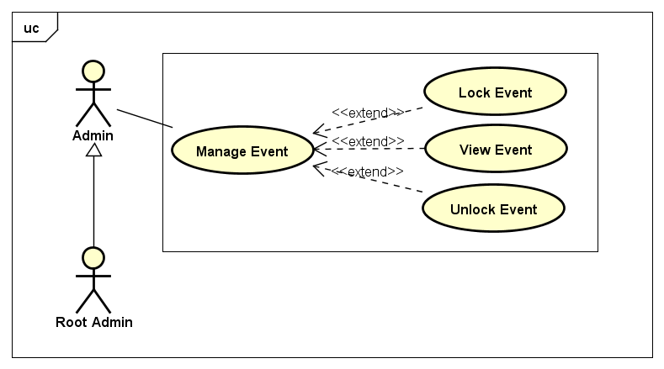

##### UC-047: View Event

|  |  |  |  |  |
| --- | --- | --- | --- | --- |
| Use Case Name | View Event | | | |
| Use Case ID | UC-047 | | | |
| Created By | ChuongNT | **Last Updated By** | | ChuongNT |
| Date Created | 21/09/2015 | **Date Last Updated** | | 24/09/2015 |
| Actor | Admin, Root Admin | | | |
| Goal/Description | This use case allow actor View Event of website | | | |
| Pre-Condition | Actor is logged in. System current shows Manage Event Page. | | | |
| Trigger | Actor wants to view event | | | |
| Basic Path | Actor’s action | | System’s response | |
|  | 1. Click on “View Events” button | | Redirect to View Event screen | |
| Post Condition | View Event screen is displayed. System current shows  View Event Page. | | | |

##### UC-048: Lock Event

|  |  |  |  |  |  |
| --- | --- | --- | --- | --- | --- |
| Use Case Name | Lock Event | | | | |
| Use Case ID | UC-048 | | | | |
| Created By | ChuongNT | | **Last Updated By** | | ChuongNT |
| Date Created | 21/09/2015 | | **Date Last Updated** | | 29/09/2015 |
| Actor | Admin, Root Admin | | | | |
| Goal/Description | This use case allow actor lock event | | | | |
| Pre-Condition | Actor is logged in, event is unlocked. System current shows Manage Event Page. | | | | |
| Trigger | Actor wants to lock event | | | | |
| Basic Path | Actor’s action | | | System’s response | |
|  | 1. Click on “ Lock” button | | | System show notice confirm lock | |
| 1. Click “Yes” button.   *There is an exception: E1* | | | System send notification to account, event is locked, event is not displayed on website and “Lock” button change to “Unlock” button | |
| Exception Paths | E1 | Actor's Action | | System’s Response | |
| Actor click “No” button | | System back to Manage Users Page | |
| Post Condition | Event is locked. System current shows Manage Event Page. If exception occur, event is unlocked. | | | | |

##### UC-049: Unlock Event

|  |  |  |  |  |  |
| --- | --- | --- | --- | --- | --- |
| Use Case Name | Unlock Event | | | | |
| Use Case ID | UC-049 | | | | |
| Created By | ChuongNT | | **Last Updated By** | | ChuongNT |
| Date Created | 21/09/2015 | | **Date Last Updated** | | 29/09/2015 |
| Actor | Admin, Root Admin | | | | |
| Goal/Description | This use case allow actor unlock event | | | | |
| Pre-Condition | Actor is logged in, Event is locked. System current shows Manage Event Page. | | | | |
| Trigger | Actor wants to unlock event | | | | |
| Basic Path | Actor’s action | | | System’s response | |
|  | 1. Click on “ Unlock” button | | | System show notice confirm unlock | |
| 1. Click “Yes” button.   *There is an exception: E1* | | | System send notification to account, event is unlocked and “Unlock” button change to “Lock” button | |
| Exception Paths | E1 | Actor's Action | | System’s Response | |
| Actor click “No” button | | System back to Manage Users Page | |
| Post Condition | Event is unlocked. System current shows Manage Event Page. If exception occur, event is locked. | | | | |

#### UC-050: Search

|  |  |  |  |  |
| --- | --- | --- | --- | --- |
| Use Case Name | Search | | | |
| Use Case ID | UC-050 | | | |
| Created By | ChuongNT | **Last Updated By** | | ChuongNT |
| Date Created | 21/09/2015 | **Date Last Updated** | | 29/09/2015 |
| Actor | Admin, Root Admin | | | |
| Goal/Description | Allow Actor find out the user information or event which match the inputted text. | | | |
| Pre-Condition | Actor is sign in. | | | |
| Trigger | Actor wants to search user or event . | | | |
|  | Actor’s Action | | System’s Response | |
| Basic Path | 1. Input text to the search bar | |  | |
| 1. Click on “Search” button   There is an alternative A1, there is an exception E1. | | Result screen will display | |
| Alternative Paths | A1.Actor press “Enter” | | Result screen will display | |
| Exception Paths | E1. If Actor press “Enter” while search bar is empty. | | Show the notice “Let’s fill your text to search !” | |
| Post Condition | Actor is staying on Result screen which has all matching search results. | | | |

#### Manage Reports/Appeals

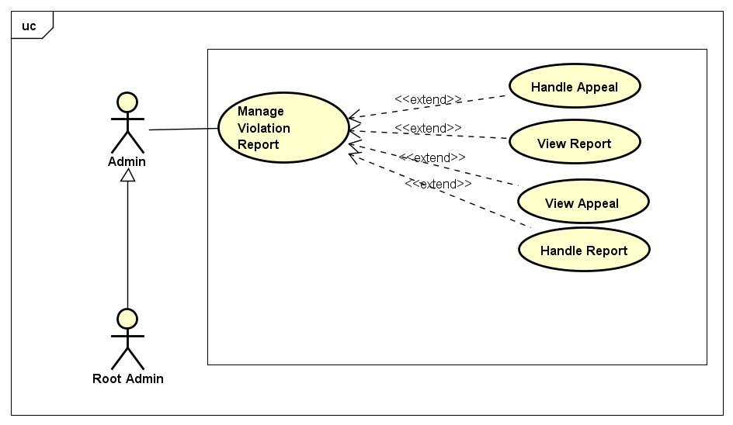

##### UC-051: View Reports/Appeals

|  |  |  |  |  |
| --- | --- | --- | --- | --- |
| Use Case Name | View Users | | | |
| Use Case ID | UC-051 | | | |
| Created By | ChuongNT | **Last Updated By** | | ChuongNT |
| Date Created | 22/09/2015 | **Date Last Updated** | | 29/09/2015 |
| Actor | Admin, Root Admin | | | |
| Goal/Description | This use case allow Actor view all report/appeal | | | |
| Pre-Condition | Actor is logged in. System current shows Manage Violation Report Page. | | | |
| Trigger | Actor wants to view all report in Event Zone’s system. | | | |
|  | Actor’s Action | | System’s Response | |
| Basic Path | 1. Click “View Reports/Appeals” button | | Redirect to the View Violation Report Screen | |
| Post Condition | Actor can view all users. System current shows View Reports/Appeals Page. | | | |

##### UC-052: Handle Report

|  |  |  |  |  |  |  |
| --- | --- | --- | --- | --- | --- | --- |
| Use Case Name | Handle Report | | | | | |
| Use Case ID | UC-052 | | | | | |
| Created By | ChuongNT | | **Last Updated By** | | | ChuongNT |
| Date Created | 22/09/2015 | | **Date Last Updated** | | | 29/09/2015 |
| Actor | Admin, Root Admin | | | | | |
| Goal/Description | This use case allow Actor handles user’s report. | | | | | |
| Pre-Condition | Actor is logged in. System current shows Manage Violation Report Page. | | | | | |
| Trigger | Actor wants to handle report. | | | | | |
| Basic Path | Actor’s Action | | | | System’s response | |
| 1. Actor selects a pending report from list report. | | | | Redirects to view report detail. | |
| 1. Actor select and click on button in action area(): | | | |  | |
| * + Actor click on button “Approve” | | | | * + System change report status to “Approved”. | |
| * + Actor click on button “Reject” | | | | * + System change report to status “Rejected” | |
| 1. Actor click on button “Save”   *There is an exception E1* | | | | System update report and save to database. System informs to user that handling successful and redirect to Manage reports page. | |
| Exception Paths | **E1** | Actor’s Action | | System’s response | | |
| 3. Actor click on button “Cancel” | | System displays exit handling report confirmation pop-up. | | |
| Notes | There are 3 status of report:   * “Pending” report: report is not handled. * “Approved” report: report is determined that the information given in the report is exactly and it must be handle. * “Reject” report: report determined that the information given in the report is not true and it will be ignore. | | | | | |
| Post Condition | Report status is updated. System current shows Manage Violation Report Page. If exception occur, system response based on exception. | | | | | |

##### UC-053: Handle Appeal

|  |  |  |  |  |  |  |
| --- | --- | --- | --- | --- | --- | --- |
| Use Case Name | Handle Report | | | | | |
| Use Case ID | UC-053 | | | | | |
| Created By | ChuongNT | | **Last Updated By** | | | ChuongNT |
| Date Created | 22/09/2015 | | **Date Last Updated** | | | 29/09/2015 |
| Actor | Admin, Root Admin | | | | | |
| Goal/Description | This use case allow Actor handles user’s appeal. | | | | | |
| Pre-Condition | Actor is logged in. System current shows Manage Violation Report Page. | | | | | |
| Trigger | Actor wants to handles appeals. | | | | | |
| Post Condition | Appeal status is updated. System current shows Manage Violation Report Page. If exception occur, system response based on exception. | | | | | |
| Basic Path | Actor’s Action | | | | System’s response | |
| 1. Actor selects a pending appeal from list appeal. | | | | Redirects to view appeal detail. | |
| 1. Actor select and click on button in action area(): | | | |  | |
| * + Actor click on button “Approve” | | | | * + System change appeal status to “Approved”. | |
| * + Actor click on button “Reject” | | | | * + System change appeal to status “Rejected” | |
| 1. Actor click on button “Save”   *There is an exception E1* | | | | System update appeal and save to database. System informs to user that handling successful and redirect to Manage Violation Report page. | |
| Exception Paths | **E1** | Actor’s Action | | System’s response | | |
| 3. Actor click on button “Cancel” | | System displays exit handling report confirmation pop-up. | | |
| Notes | There are 3 status of appeal:   * “Pending” appeal: appeal is not handled. * “Approved” appeal: appeal is determined that the information given in the appeal is exactly and it must be handle. * “Reject” appeal: appeal determined that the information given in the appeal is not true and it will be ignore. | | | | | |
| Post Condition | Appeal status is updated. System current shows Manage Violation Report Page. If exception occur, system response based on exception. | | | | | |

#### Manage Admin

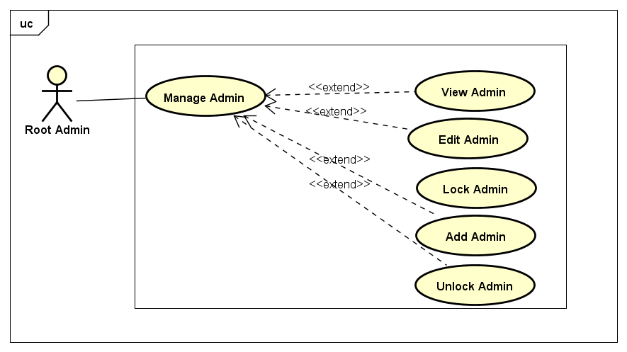

##### UC-054: View Admin

|  |  |  |  |  |  |  |
| --- | --- | --- | --- | --- | --- | --- |
| Use Case Name | Handle Report | | | | | |
| Use Case ID | UC-054 | | | | | |
| Created By | ChuongNT | | **Last Updated By** | | | ChuongNT |
| Date Created | 22/09/2015 | | **Date Last Updated** | | | 29/09/2015 |
| Actor | Admin, Root Admin | | | | | |
| Goal/Description | This use case allow Actor handles user’s appeal. | | | | | |
| Pre-Condition | Actor is logged in. System current shows Manage Violation Report Page. | | | | | |
| Trigger | Actor wants to handles appeals. | | | | | |
| Post Condition | Appeal status is updated. System current shows Manage Violation Report Page. If exception occur, system response based on exception. | | | | | |
| Basic Path | Actor’s Action | | | | System’s response | |
| 1. Actor selects a pending appeal from list appeal. | | | | Redirects to view appeal detail. | |
| 1. Actor select and click on button in action area(): | | | |  | |
| * + Actor click on button “Approve” | | | | * + System change appeal status to “Approved”. | |
| * + Actor click on button “Reject” | | | | * + System change appeal to status “Rejected” | |
| 1. Actor click on button “Save”   *There is an exception E1* | | | | System update appeal and save to database. System informs to user that handling successful and redirect to Manage Violation Report page. | |
| Exception Paths | **E1** | Actor’s Action | | System’s response | | |
| 3. Actor click on button “Cancel” | | System displays exit handling report confirmation pop-up. | | |
| Notes | There are 3 status of appeal:   * “Pending” appeal: appeal is not handled. * “Approved” appeal: appeal is determined that the information given in the appeal is exactly and it must be handle. * “Reject” appeal: appeal determined that the information given in the appeal is not true and it will be ignore. | | | | | |
| Post Condition | Appeal status is updated. System current shows Manage Violation Report Page. If exception occur, system response based on exception. | | | | | |

##### UC-055: Add Admin

|  |  |  |  |  |  |
| --- | --- | --- | --- | --- | --- |
| Use Case Name | Add Admin | | | | |
| Use Case ID | UC-055 | | | | |
| Created By | ChuongNT | **Last Updated By** | | | ChuongNT |
| Date Created | 21/09/2015 | **Date Last Updated** | | | 29/09/2015 |
| Actor | Root Admin | | | | |
| Goal/Description | This use case allow actor create new admin account | | | | |
| Pre-Condition | Actor is logged in. System current shows Manage Admin Page. | | | | |
| Trigger | Actor wants to create new admin account | | | | |
| Post Condition | Admin account added to the database. System current shows Manage Admin Page. | | | | |
| Basic Path | Actor’s action | | | System’s response | |
|  | 1. Click on “Add Admin” button | | | Redirect to Add Admin Screen | |
| 1. Fill the information of an account to field about username and password.   *There is an exception E1, E2, E3, E4* | | |  | |
| 1. Click on “Add” button to add an account | | | Redirect to Add Admin Screen | |
| Alternative Paths |  | | | | |
| Exception Paths | E1. If user did not enter username | | The screen will show the notice “username is not null” | | |
| E2If user did not enter password | | The screen will show the notice “password is not null” | | |
| E3 If user did not re-enter password | | The screen will show the notice “re-enter password is not null” | | |
| E4.If user re-enter password that not matched with the password above | | The screen will show the notice “password is incorrect” | | |
| Notes |  | | | | |

##### UC-056: Edit Admin

|  |  |  |  |  |  |
| --- | --- | --- | --- | --- | --- |
| Use Case Name | Edit Admin | | | | |
| Use Case ID | UC-056 | | | | |
| Created By | ChuongNT | | **Last Updated By** | | ChuongNT |
| Date Created | 21/09/2015 | | **Date Last Updated** | | 22/09/2015 |
| Actor | Root Admin | | | | |
| Goal/Description | This use case allow actor edit information of Admin account | | | | |
| Pre-Condition | Actor is logged in | | | | |
| Trigger | Actor wants to edit admin information. | | | | |
| Post Condition | Admin account is edited | | | | |
| Basic Path | Actor’s action | | | System’s response | |
|  | 1. Click on “Edit” button.   *There is an alternative path : A1* | | | Redirect to Edit Admin Screen | |
| 1. Edit the information of an account to field about username and password.   *There is an exception: E1* | | |  | |
| 1. Click on “Save” button to add an account | | | Redirect to Edit Admin Screen | |
| Alternative Paths | **A1.** | Actor’s Action | | System’s Respone | |
| Click on button edit “Edit” in the right top of admin. | |  | |
| Exception Paths | E1 | 2.1 If username is blank | | 2.1 The screen will show the notice “username is not null” | |
| 2.2 If password is blank | | 2.2 The screen will show the notice “password is not null” | |
| 2.3 If re-enter password is blank | | 2.3 The screen will show the notice “re-enter password is not null” | |
| 2.4 If user re-enter password that not matched with the password above | | 2.4 The screen will show the notice “password is incorrect” | |
| Notes |  | | | | |

##### UC-058: Lock Admin

|  |  |  |  |  |  |
| --- | --- | --- | --- | --- | --- |
| Use Case Name | Lock Admin | | | | |
| Use Case ID | UC-058 | | | | |
| Created By | ChuongNT | | **Last Updated By** | | ChuongNT |
| Date Created | 21/09/2015 | | **Date Last Updated** | | 24/09/2015 |
| Actor | Root Admin | | | | |
| Goal/Description | This use case allow actor lock admin | | | | |
| Pre-Condition | Actor is logged in, Admin is unlocked. System current shows Manage Admin Page. | | | | |
| Trigger | Actor wants to lock admin | | | | |
| Post Condition | Admin is locked. System current shows Manage Admin Page. If exception occur, admin account is unlocked. | | | | |
| Basic Path | Actor’s action | | | System’s response | |
|  | 1. Click on “Lock” button | | | System show notice confirm lock | |
| 1. Click “Yes” button.E1 | | | Admin is locked, “Lock” button change to “Unlock” button | |
| Alternative Paths |  | | | | |
| Exception Paths | E1 | Actor's Action | | System’s Response | |
| Actor click “No” button | | System back to Manage Users Page | |
| Notes |  | | | | |

##### UC-059: Unlock Admin

|  |  |  |  |  |  |
| --- | --- | --- | --- | --- | --- |
| Use Case Name | Unlock Admin | | | | |
| Use Case ID | UC-059 | | | | |
| Created By | ChuongNT | | **Last Updated By** | | ChuongNT |
| Date Created | 21/09/2015 | | **Date Last Updated** | | 24/09/2015 |
| Actor | Root Admin | | | | |
| Goal/Description | This use case allow actor unlock Admin | | | | |
| Pre-Condition | Actor is logged in, Admin is locked. System current shows Manage Admin Page. | | | | |
| Trigger | Actor wants to unlock admin | | | | |
| Post Condition | Event is unlocked. System current shows Manage Admin Page. If exception occur, admin is locked. | | | | |
| Basic Path | Actor’s action | | | System’s response | |
|  | 1. Click on “ Unlock” button | | | System show notice confirm unlock | |
| 1. Click “Yes” button.E1 | | | Admin is unlock, “Unlock” button change to “Lock” button | |
| Alternative Paths |  | | | | |
| Exception Paths | E1 | Actor's Action | | System’s Response | |
| Actor click “No” button | | System back to Manage Users Page | |
| Notes |  | | | | |

## Non-functional Requirements

### Usability

* Interface should be simple, easy-to-use, clear
* Color should be gentle
* Take maximum 30 minutes for normal user to become productive at particular operations
* Take maximum 1 hour 30 minutes for user to learn streaming video
* User can understand approximately 90% help/error messages

### Reliability

* Availability:
  + Of server: 160/168 hours every week
  + Of website: 160/168 hours every week
* Mean Time Between Failures (MTBF): Expected to be approximately 500 hours.
* Mean Time To Repair (MTTR): System is allowed to be out of operation at most 12 hours after it has failed
* Maximum Bugs or Defect Rate: 2 bugs/a function
* Database must be backed up daily for recovering if neccessary
* Search Result return must be correctly
* Location of event is corrected approximately 95%
* Reports and Appeals will be checked in at most 12 hours since submitted time by moderators/admins

### Performance

* Response Time:
  + Time for searching: At most 10s
  + Time for loading image: At most 5s
  + Time to progress any function: will not exceed 7 seconds

### Supportability

* Coding Standards and Naming Conventions
  + All code must be clearly commented, including class, method documentations
  + If some components are reused, the documentations of those components must also be included
* Design
  + Loosely coupled that chances on some modules can’t affect others
* Logging
  + Errors must be signed to support maintain and fixing bug.
  + All sensitive situations must be signed

### Design Constraints

* Software Languages: C# MVC Model
* Software Process Model: Iterative Model
* Developmental Tools: Visual Studio 2013
* Database Tools: SQL Server 2012